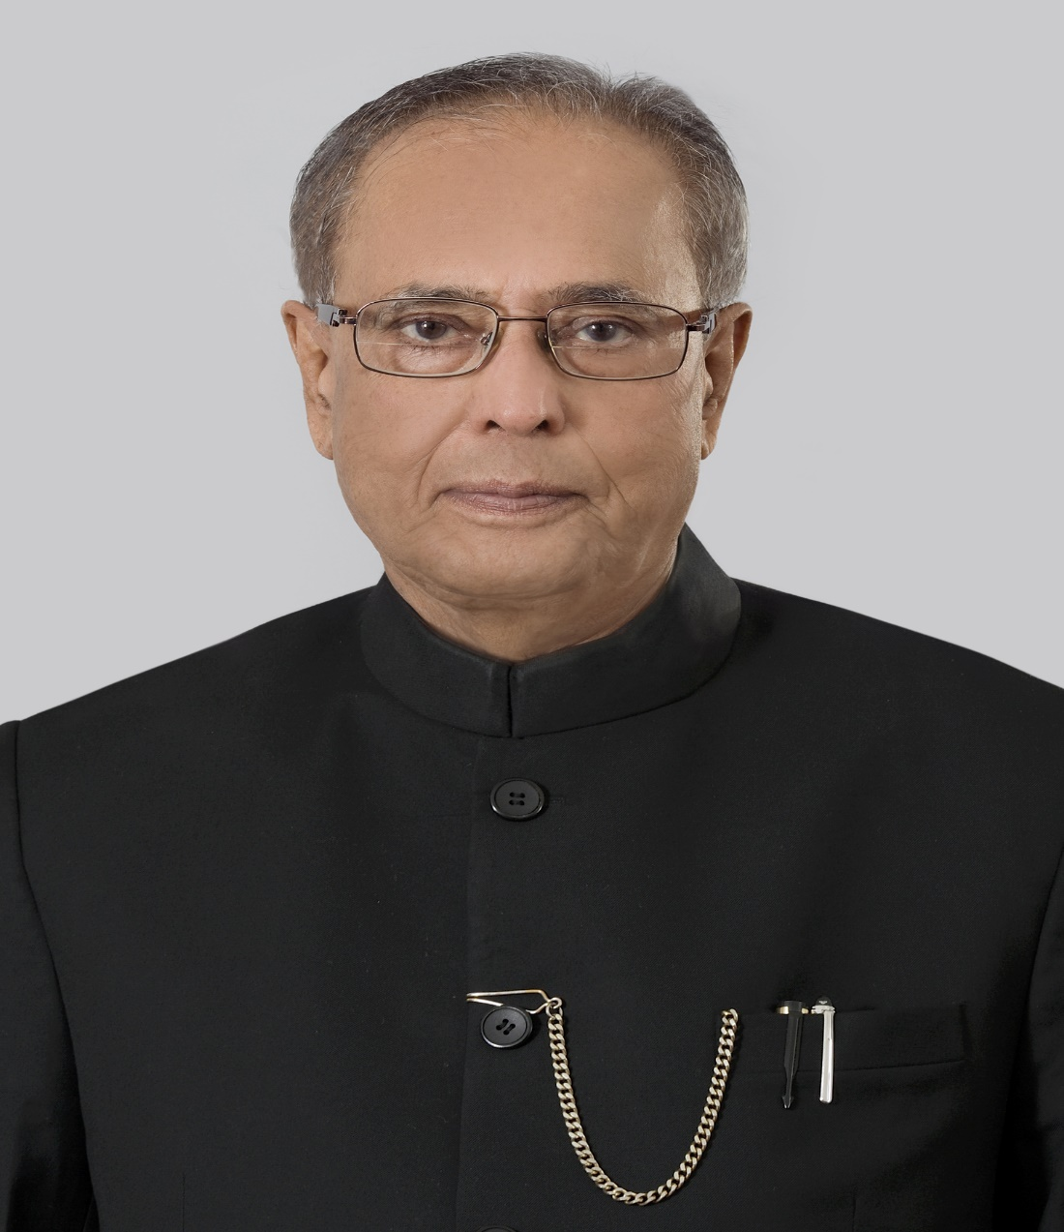

Press Release

At the invitation of His Majesty King Abdullah-II Ibn Al Hussein of the Hashemite Kingdom of Jordan, the Hon’ble President of India, Shri Pranab Mukherjee, will pay a State visit to Jordan from 10-12 October 2015. The Hon’ble President will be accompanied by Shri Thaawar Chand Gehlot, Union Minister of Social Justice and Empowerment, Members of Parliament and the learned members of the academic community, apart from official delegation and media representatives.
The visit of Hon’ble President will be the first by the President of India to Jordan in the last 65 years since the establishment of diplomatic relations between the two countries. Prime Minister Rajiv Gandhi visited Jordan in 1988. From the Jordanian side, His Majesty King Abdullah and Queen Rania visited India in 2006. The visit of Hon’ble President to Jordan underscores the desire of the two countries to strengthen their bilateral relations.
During the visit, the Hon’ble President will meet his Majesty King Abdullah and will have extensive discussions on entire gamut of bilateral relations, regional and international issues of mutual concern. The Hon’ble President will have a meeting with the Prime Minister and Deputy Prime Minister and Minister of Foreign Affairs of Jordan would call on the Hon’ble President. In the presence of the Hon’ble President of India, a number of agreements are expected to be signed during the visit. The Hon’ble President will also visit the University of Jordan and make a public speech. He will also grace a function organised by our Ambassador in Amman for Indian community and Friends of India.
****

06 October, 2015

