Ganesha artifact in Embassy
Our attention has been drawn to some erraneous news items in media on the subject. Correct position is as under.
The above Ganesha artifact was brought from India by a Kuwaiti national for display in his Diwaniya and was placed outside for house renovation.
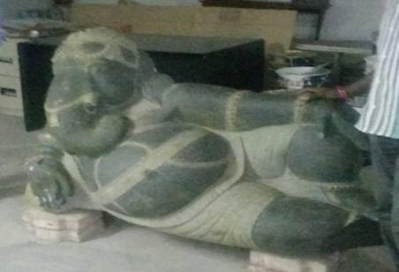
On 3 September 2015, the Embassy received a call from the owner that the artifact has been considerably damaged. The Embassy was requested to take possession of the artifact for its safety and security.
After necessary repairs by our craftsmen, the artifact has been placed in the Embassy Reception as a mark of goodwill and friendship. This repaired artifact cannot be worshiped and is not meant for worship.
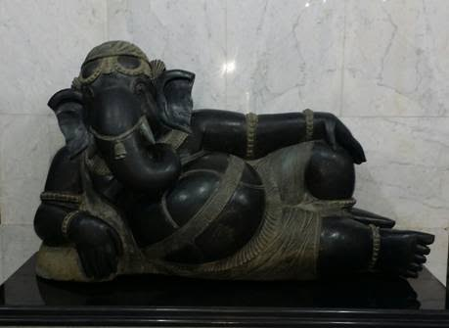
The Embassy will continue to provide its best services to all members of the community.
22 September 2015

