CELEBRATION OF ‘HINDI DIWAS’ IN
EMBASSY OF INDIA, ASHGABAT
14.09.2015

…….

‘Hindi Diwas’ celebrations were held at the Embassy of India, Ashgabat on Monday, 14 September 2015.
Ambassador Dr. T.V. Nagendra Prasad presided over the function which was attended by all the officers and staff, including locally recruited staff.
Ten Turkmen students studying Hindi language at the Azadi Institute of World Languages in Ashgabat participated in the celebrations. They were accompanied by Dr. Deepak Naresh, Hindi Chair (ICCR) and their Teacher Ms. Shirin Jepbarova.
Speaking on the occasion, Ambassador appreciated the competence of the Turkmen students in understanding and speaking of Hindi. A quiz competition and elocution was held among Turkmen students and Indian Embassy officials on the occasion.
The celebrations concluded by distribution of prizes to all the winning Turkmen Hindi language students. The event was well appreciated by the local Hindi students.
………

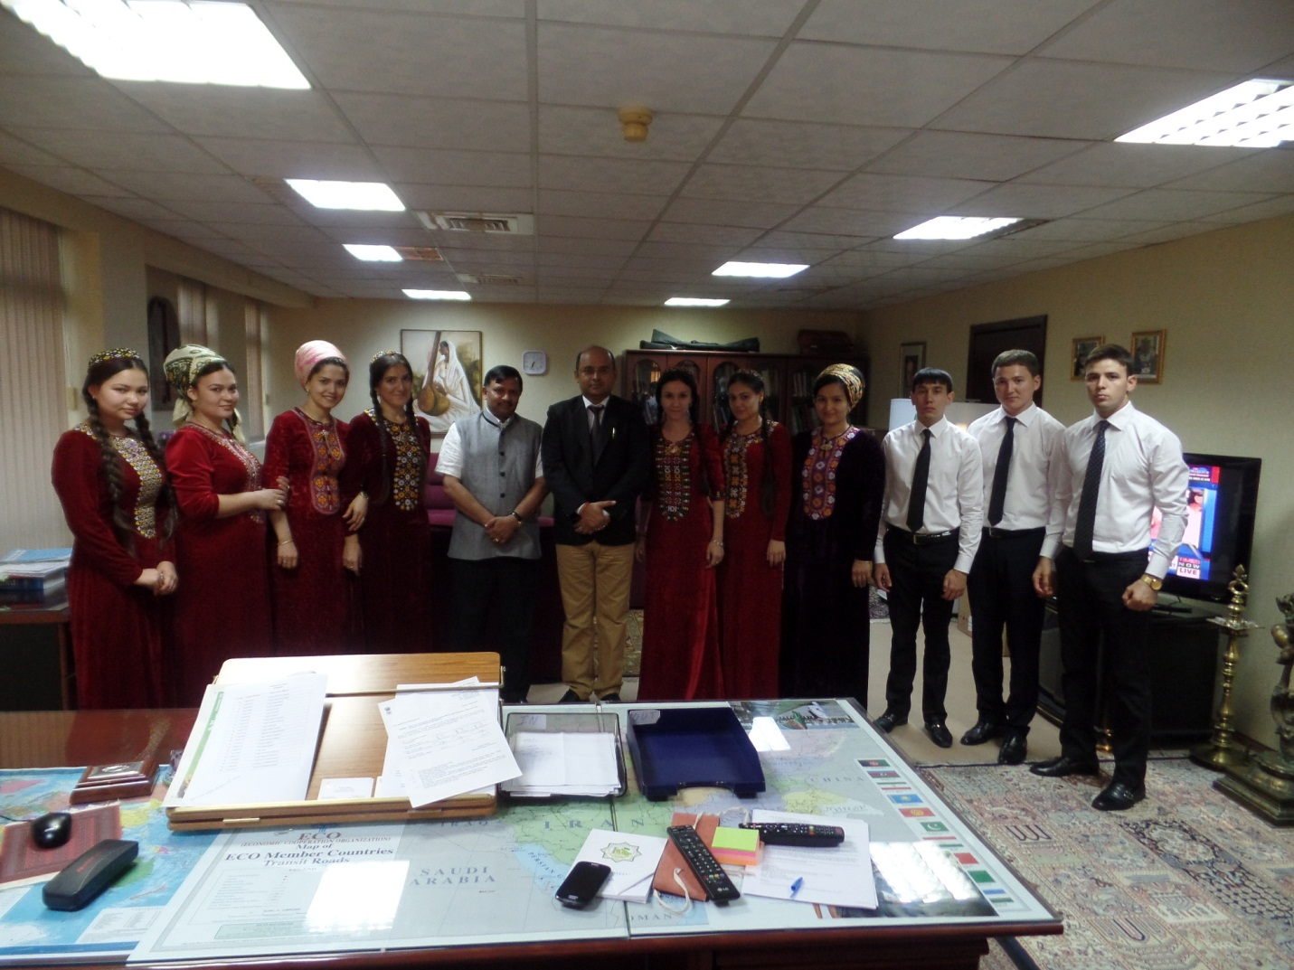
Ambassador Dr. T.V. Nagendra Prasad with Turkmen Hindi language students

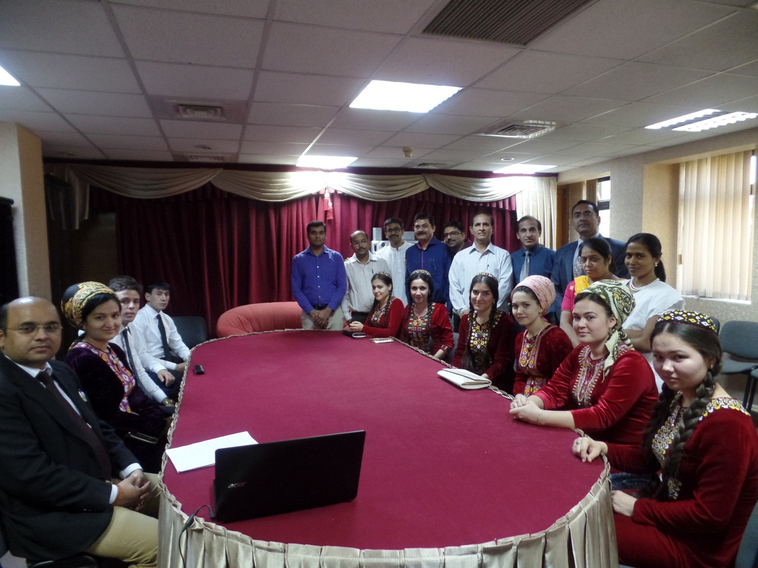
A view of the gathering at the ‘Hindi Diwas’ in E/I Ashgabat
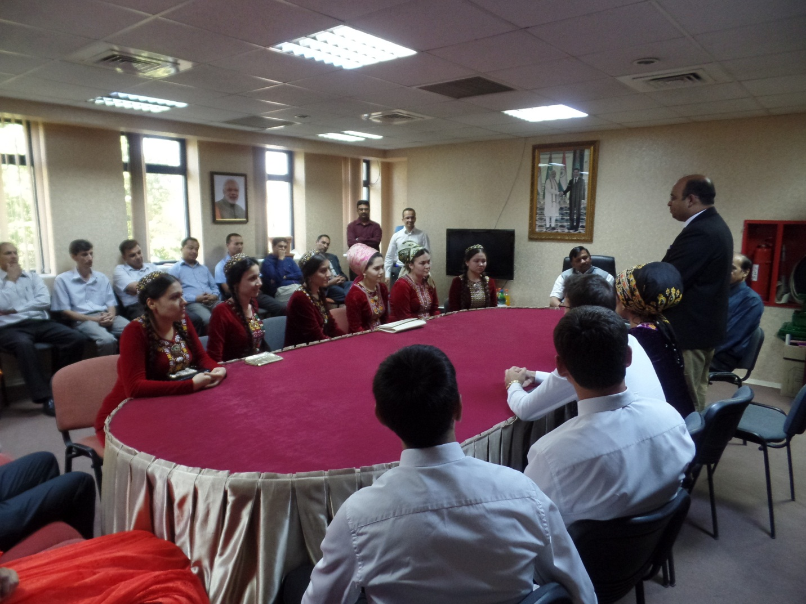
Interaction with Turkmen Hindi language students

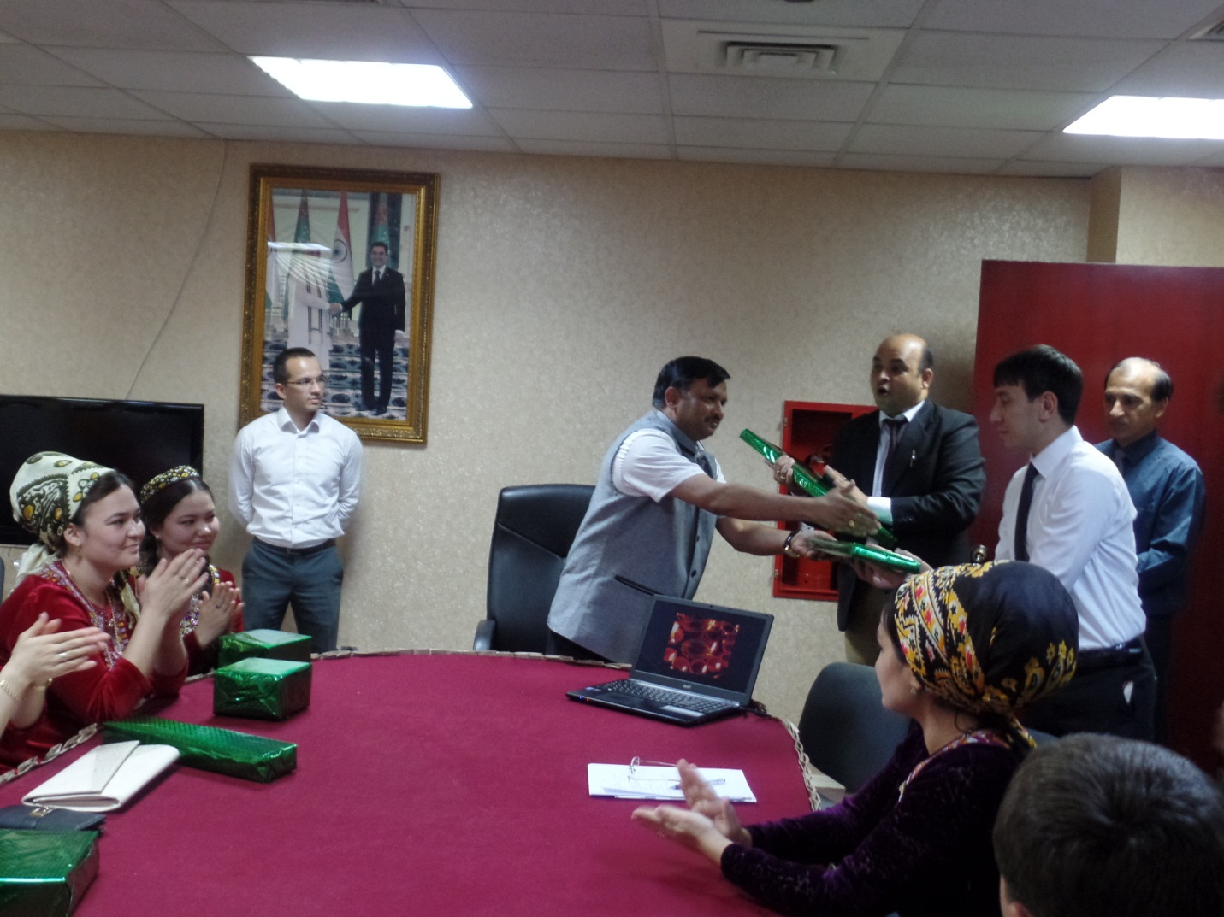
Ambassador Dr. T.V. Nagendra Prasad presenting prizes to the winner

