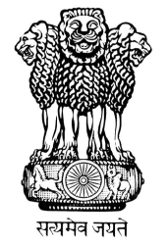

EMBASSY OF INDIA
MINSK

PRESS RELEASE

15th August 2015

The Embassy of India in Minsk celebrated the 69th Independence Day. Ambassador Manoj K. Bharti unfurled the national flag amid the presence of about 50 people which includes local Indians, friends of India, and Embassy officials and their families. The President’s speech was read by Ambassador to the gathered guests.

Ambassador also shared with the assembled guests Embassy’s performance during the last few months’ work, which included the successful visit of the Hon’ble President from June 3-6, 2015 and grand celebrations of International Day of Yoga.
