EMBASSY OF INDIA
MINSK

PRESS RELEASE

Following the sad demise of Dr. A.P.J. Abdul Kalam, former President of India on 27 July 2015, a Condolence Book was opened in the Embassy of India in Minsk from 29-30 July. The Ambassadors/representatives of Czech Republic, Sovereign Military Order of Malta, Republic of Latvia, State of Palestine, Syrian Arab Republic, Hungary, Bulgaria, United Kingdom, Kyrgyz Republic, Turkmenistan, Russia, Slovak Republic, Ukraine, Permanent Representative of Russia in CIS countries, Ecuador, Serbia, Estonia, Head of EU Delegation, Austrian, Iran, Venezuela and Libya signed the Condolence Book and paid their tribute to Dr. A.P.J. Abdul Kalam, former President of India.
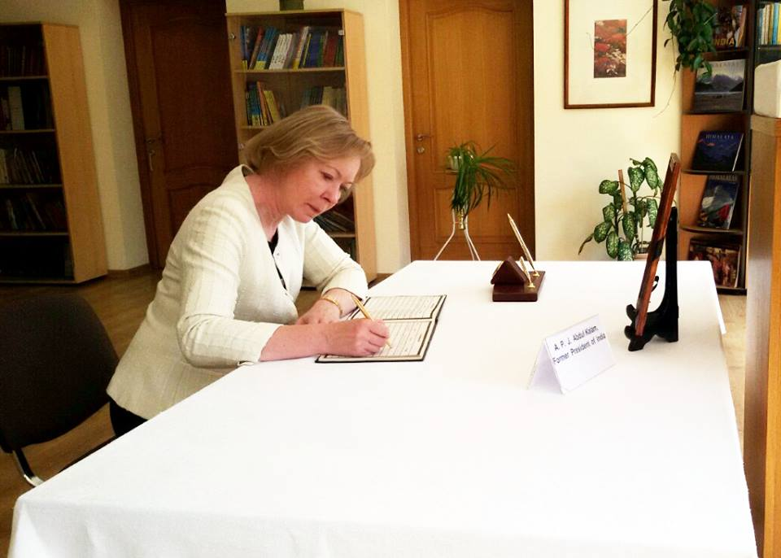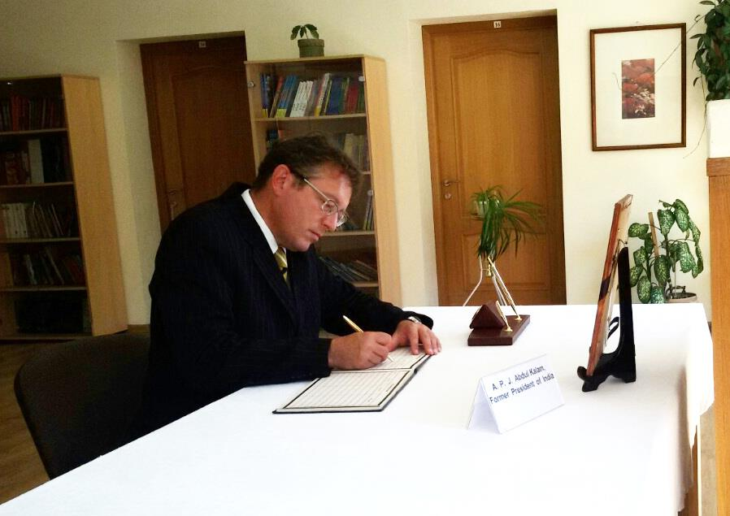
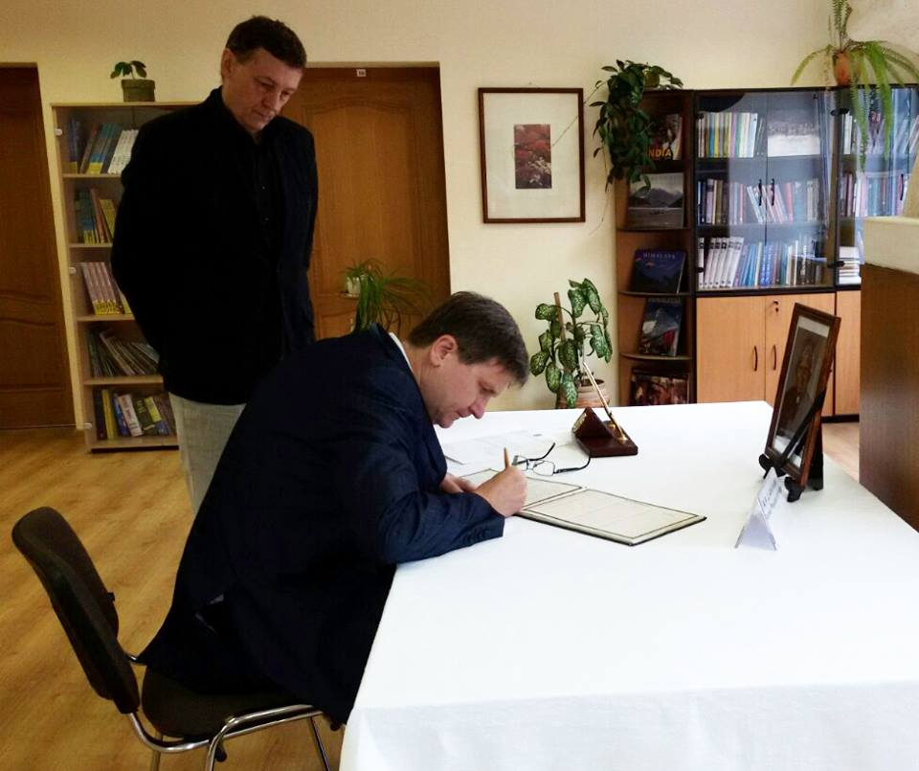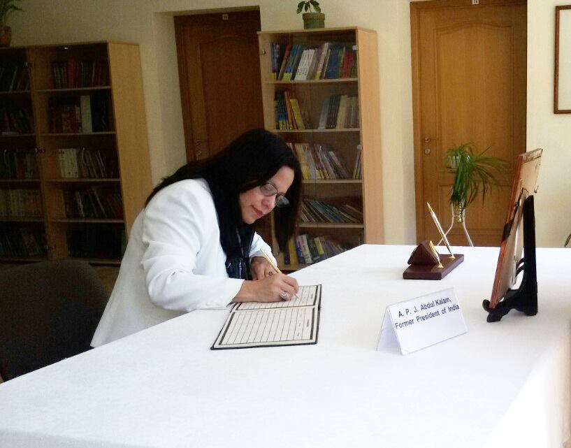

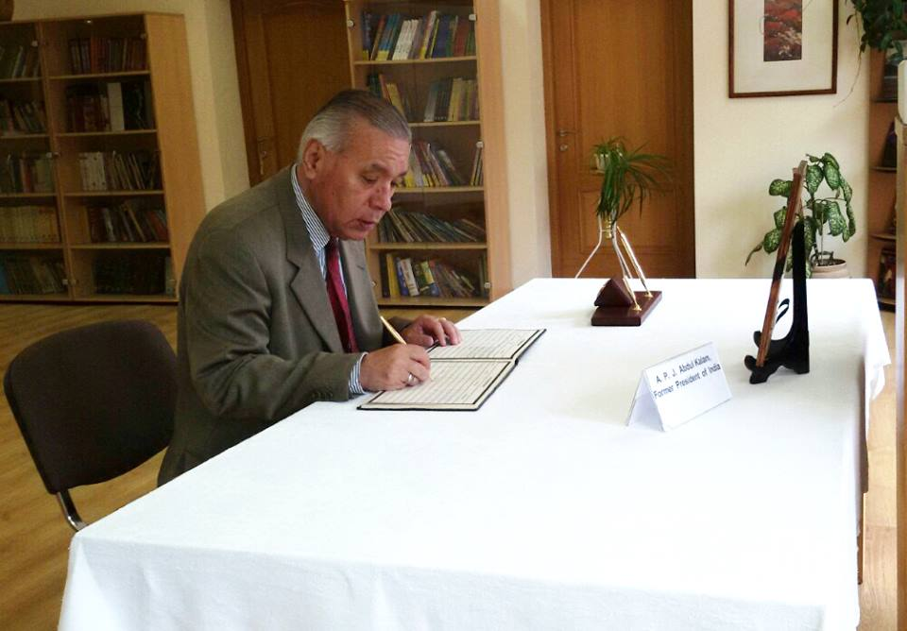

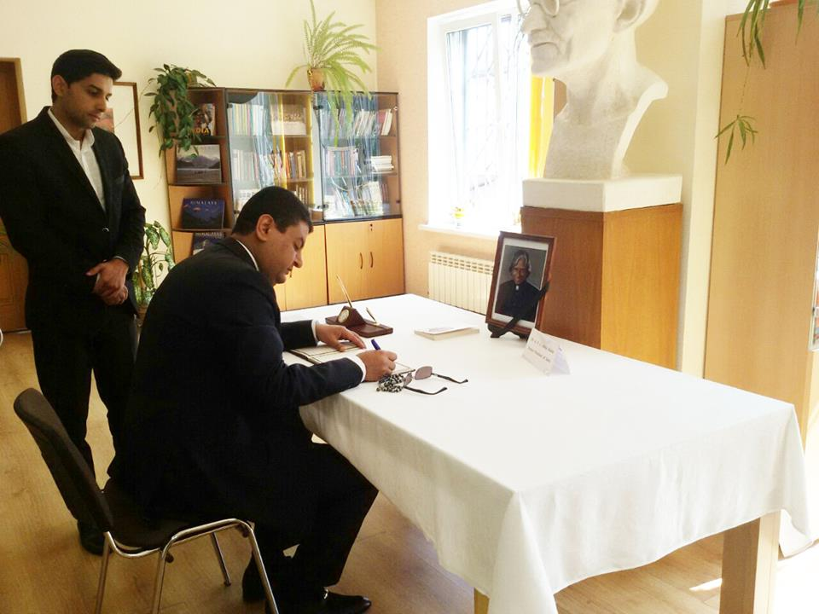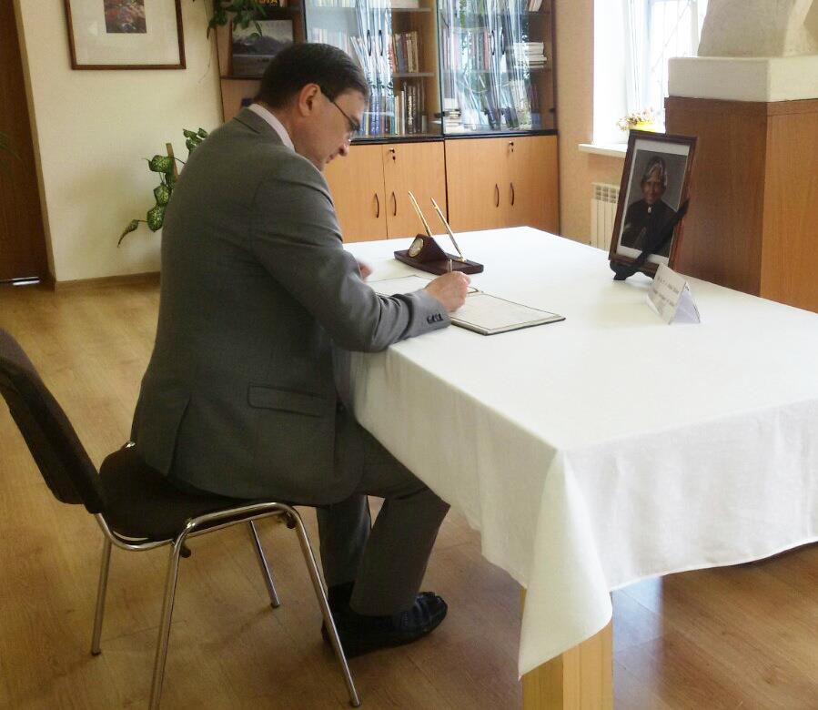
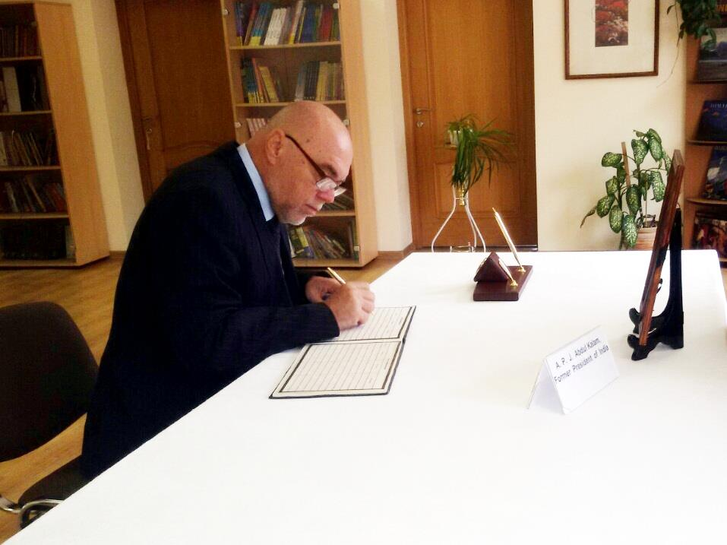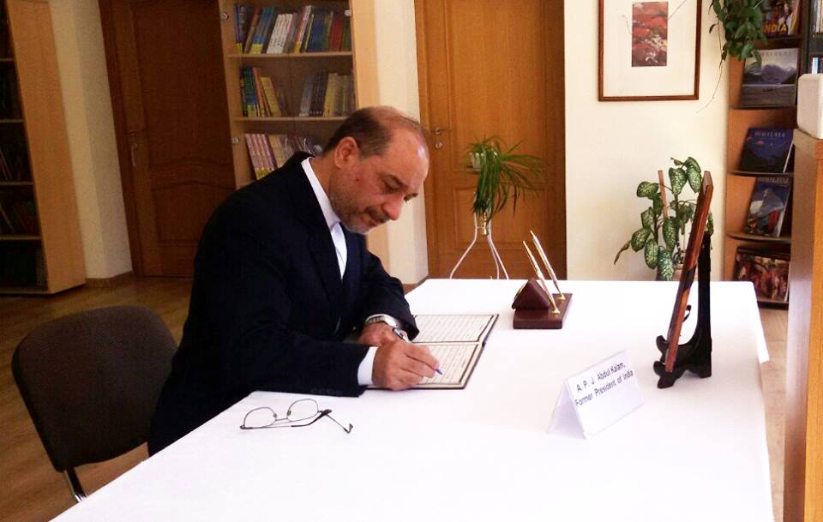

31 July 2015

