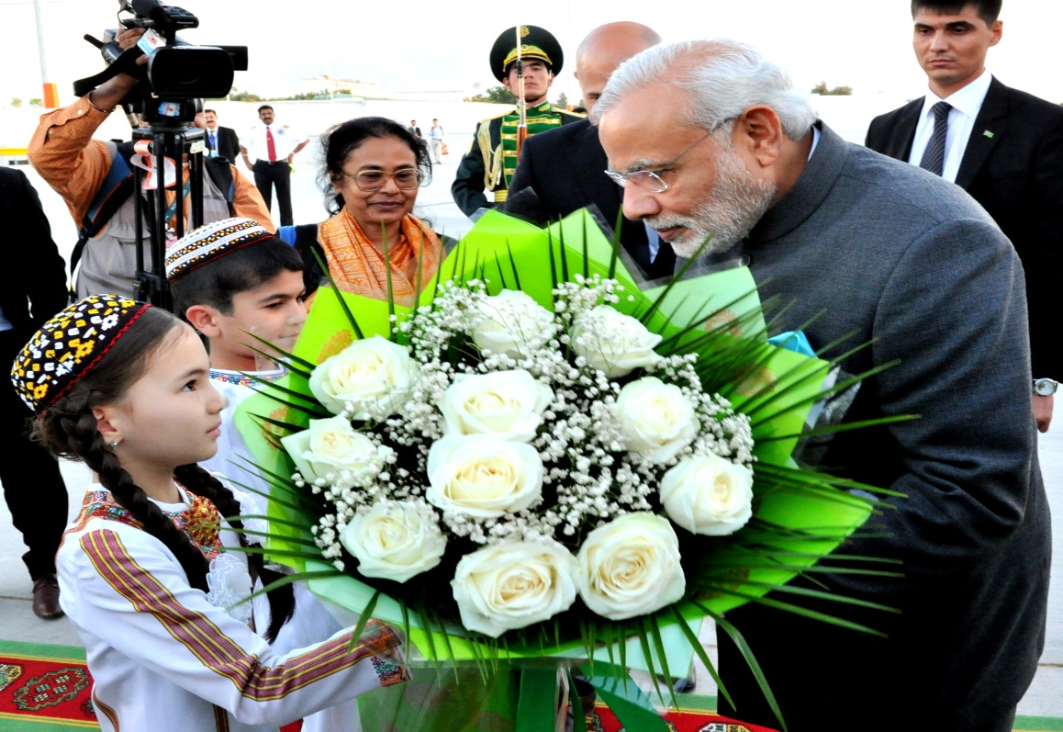
Prime Minister Shri Narendra Modi on arrival in Turkmenistan

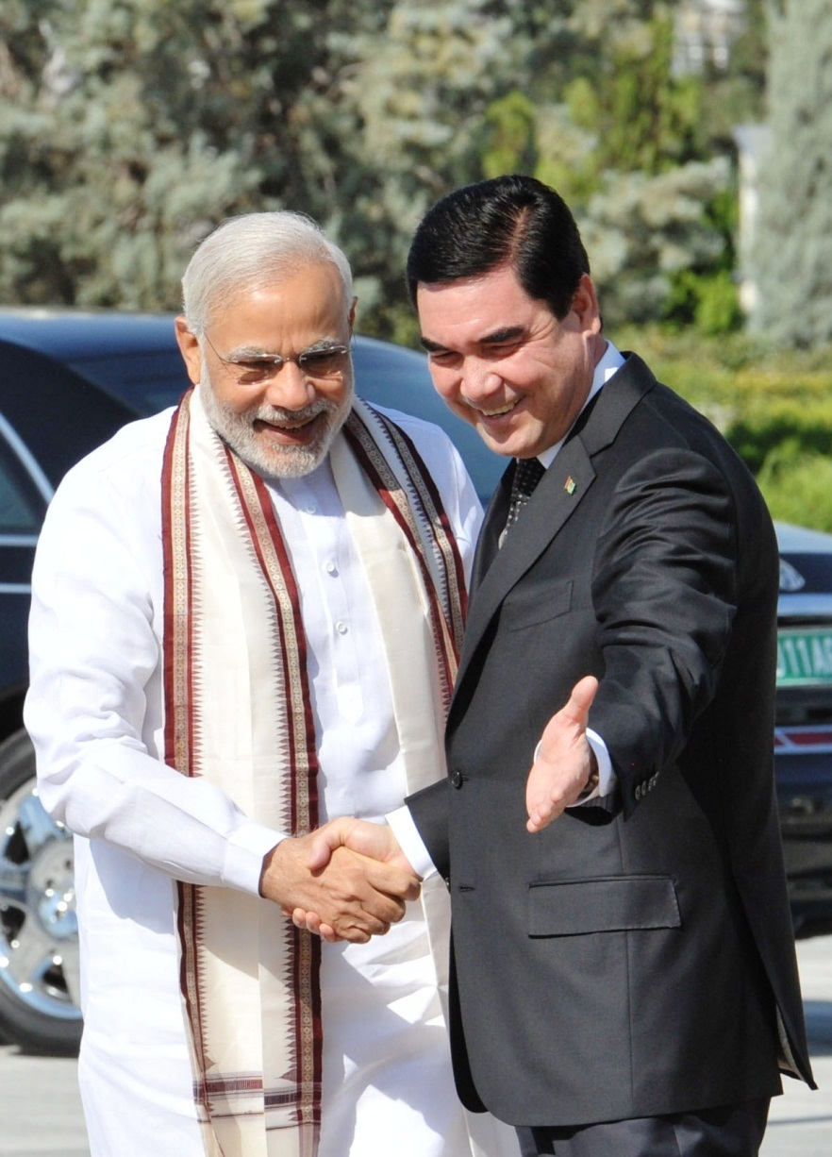

PM Narendra Modi and President Gurbanguly Berdimuhammedov

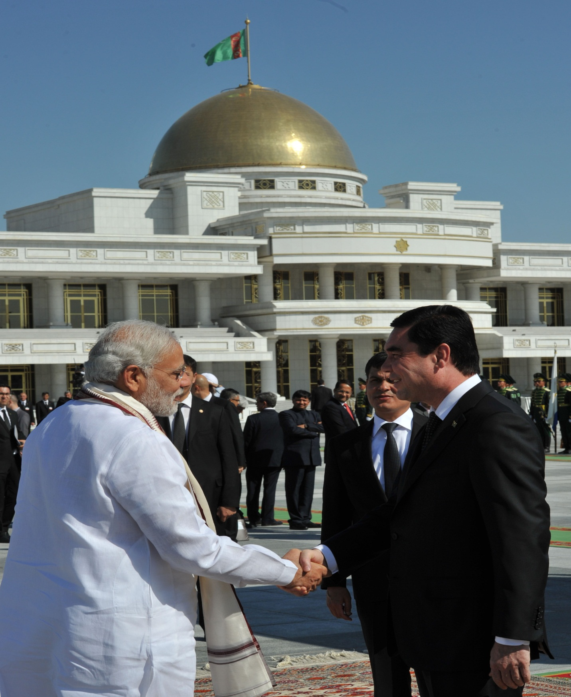
PM with President Gurbanguly Berdimuhamedov

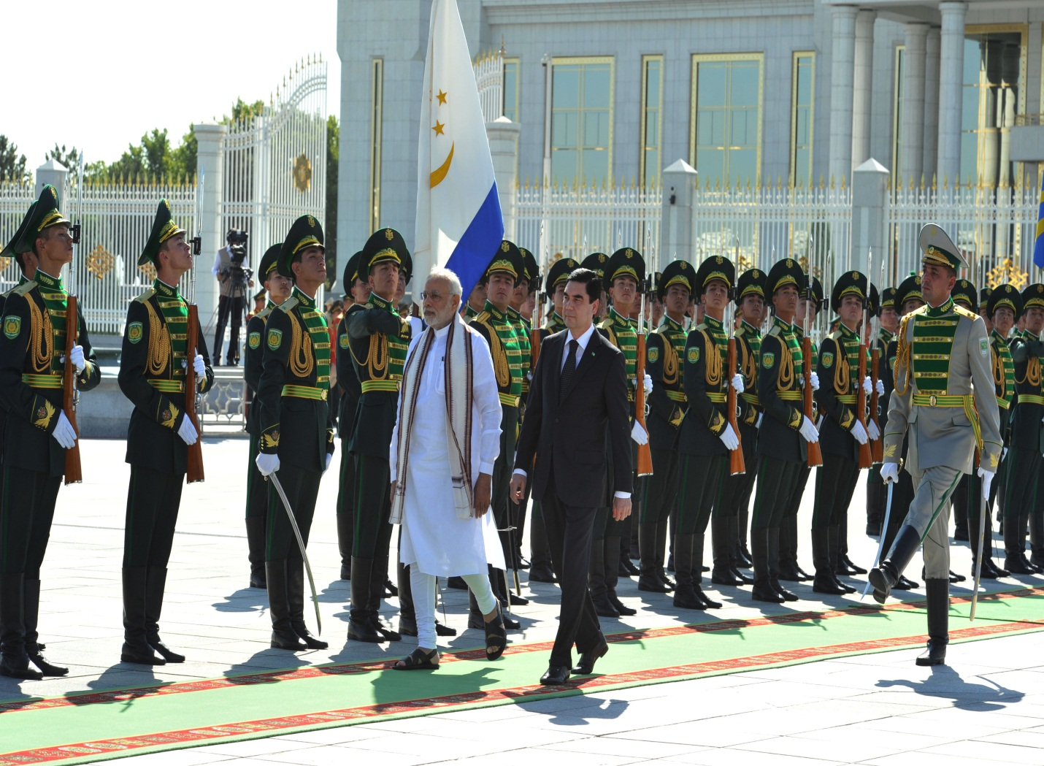

Ceremonial welcome for PM Modi

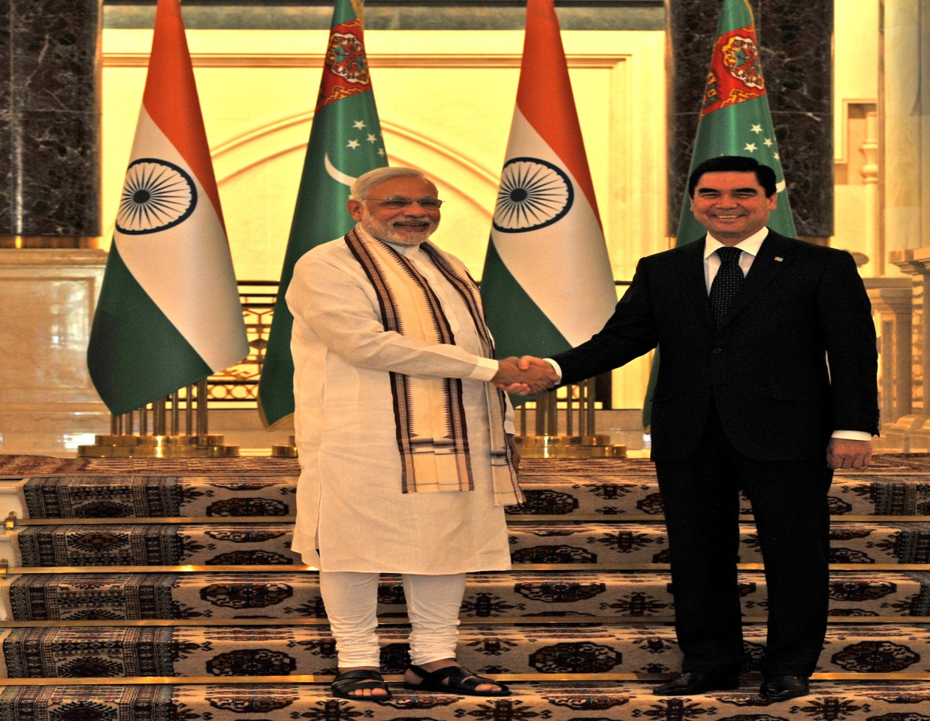
Prime Minister Shri Narendra Modi with President Gurbanguly Berdimuhamedov for tete-a-tete

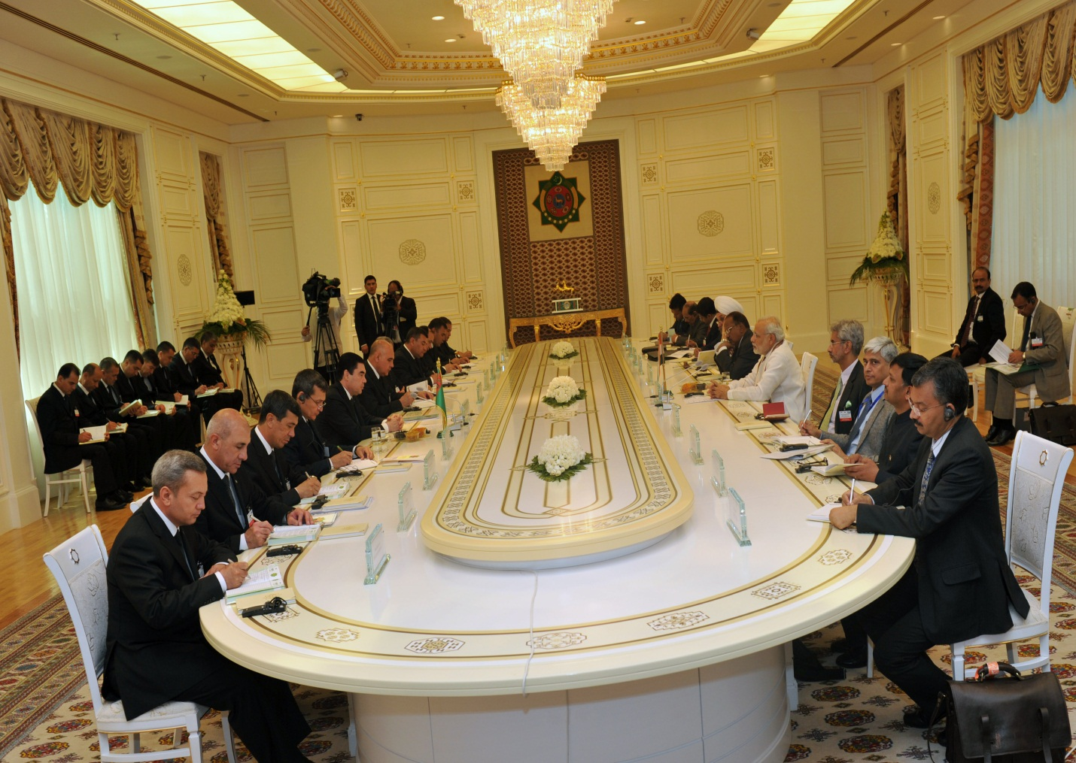
Delegation level talks

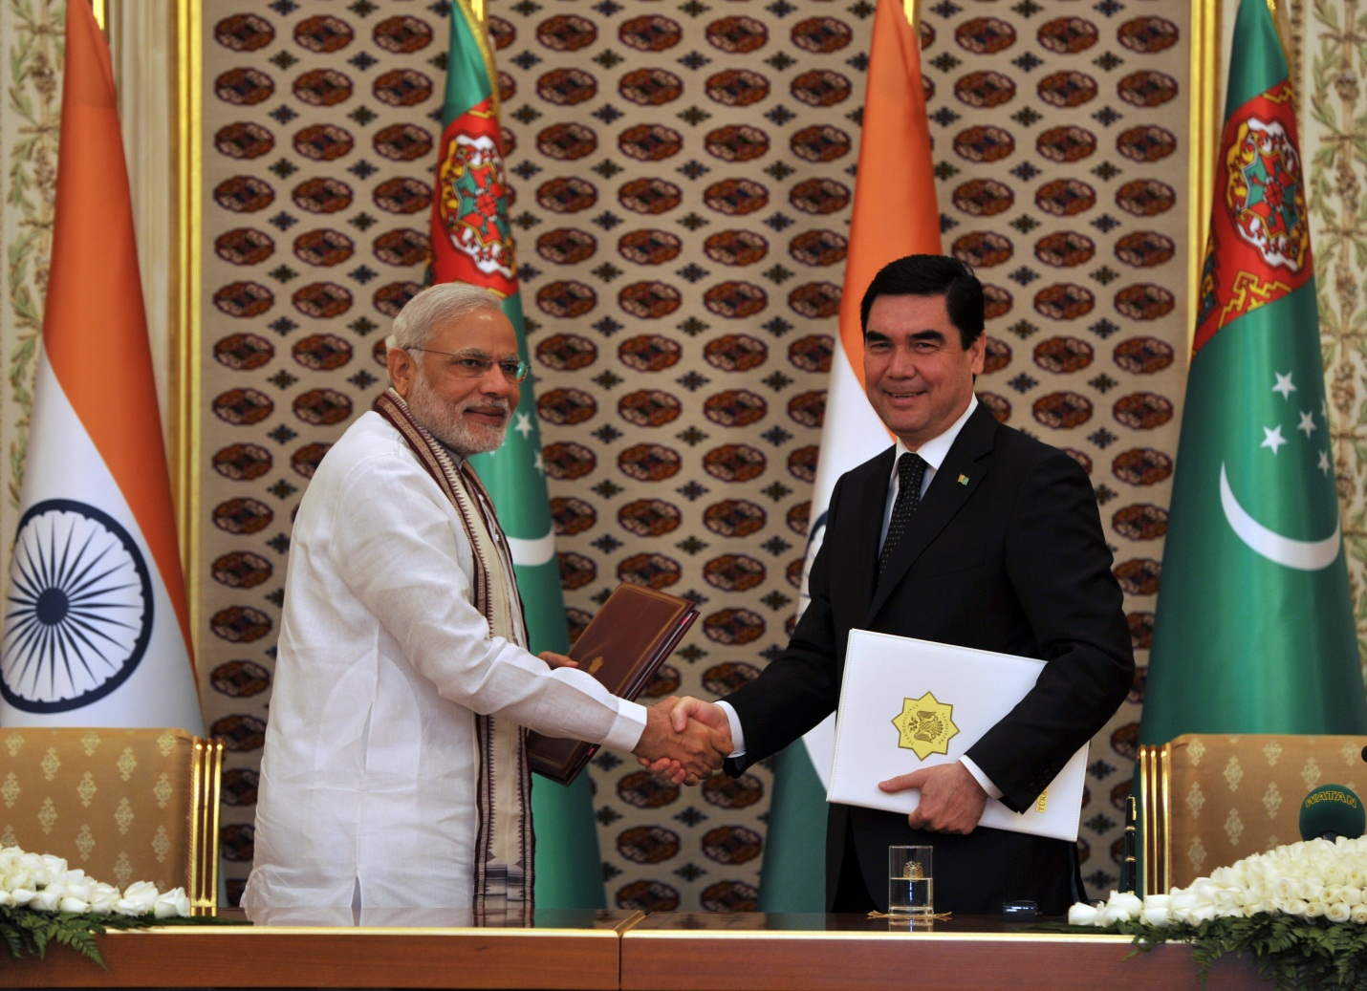
PM Modi and President Berdimuhamedov at the Press Meet

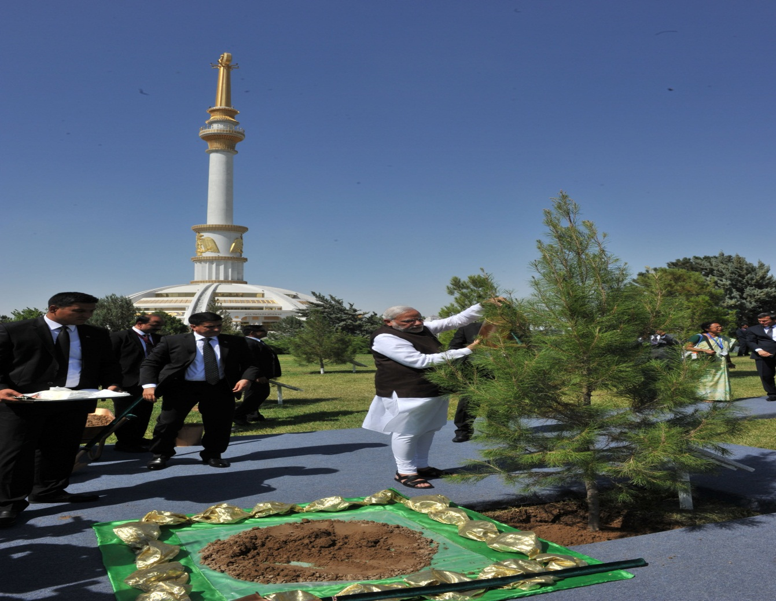
PM Modi planting a tree at the Independence Monument in Ashgabat

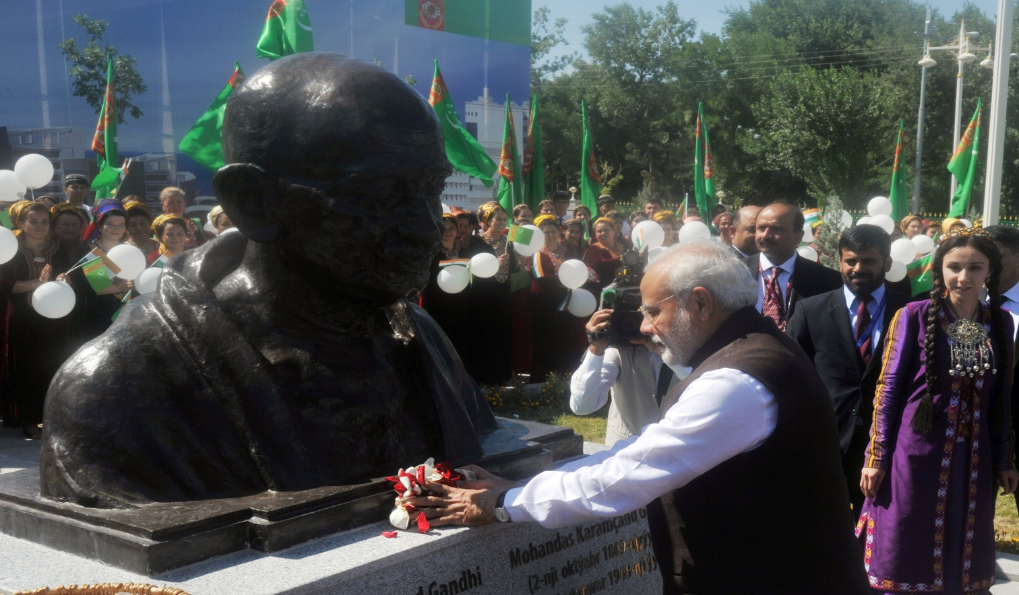
PM Modi unveiling the Bust of Mahatma Gandhi in Ashgabat

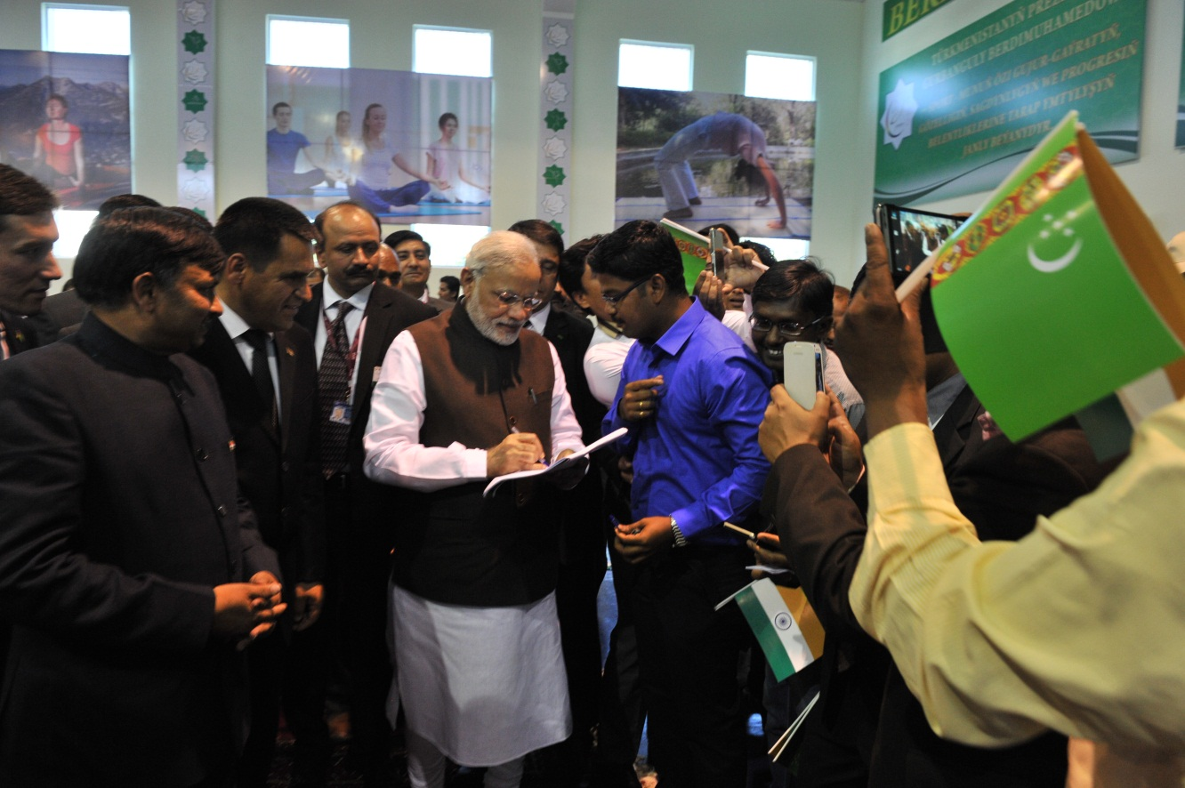
PM Modi at the Yoga Centre

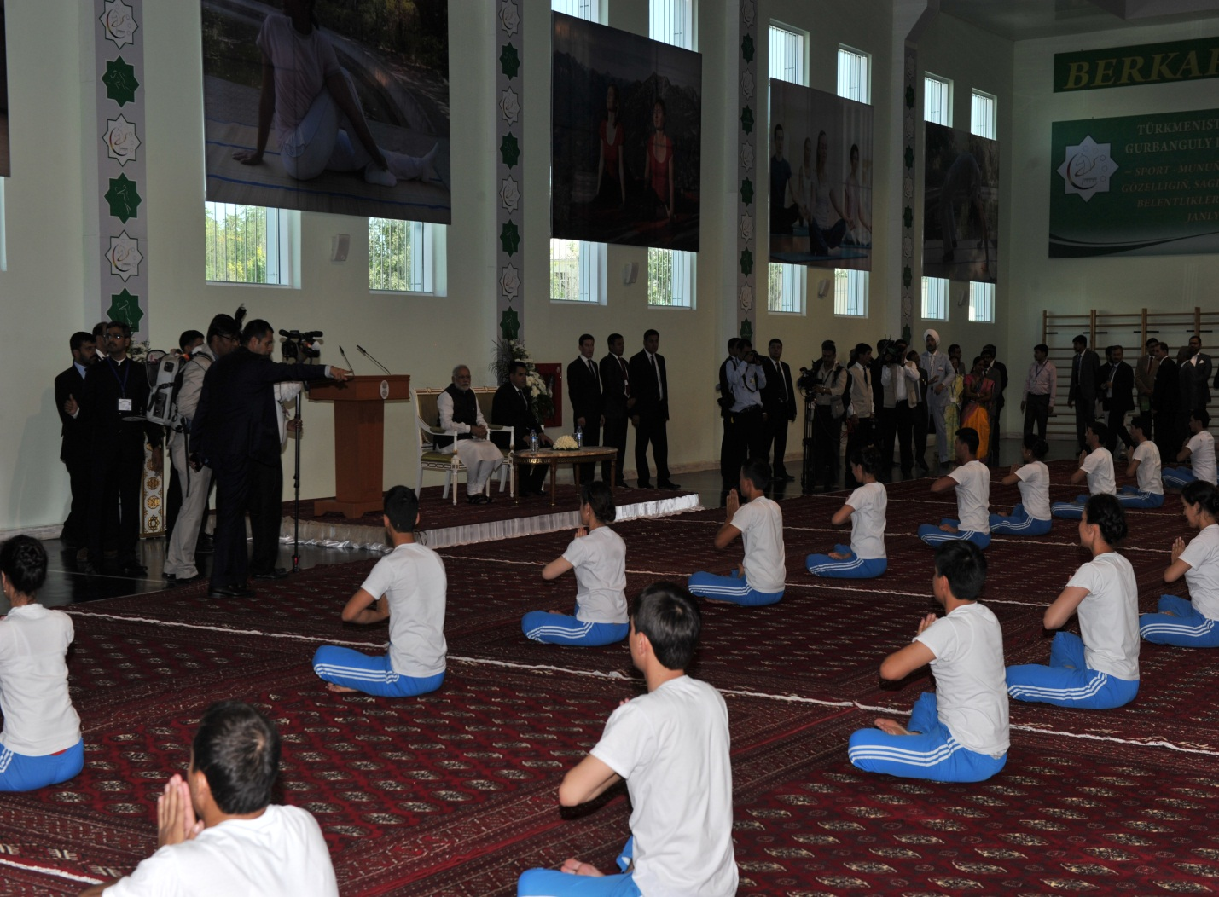
PM at the Yoga Centre

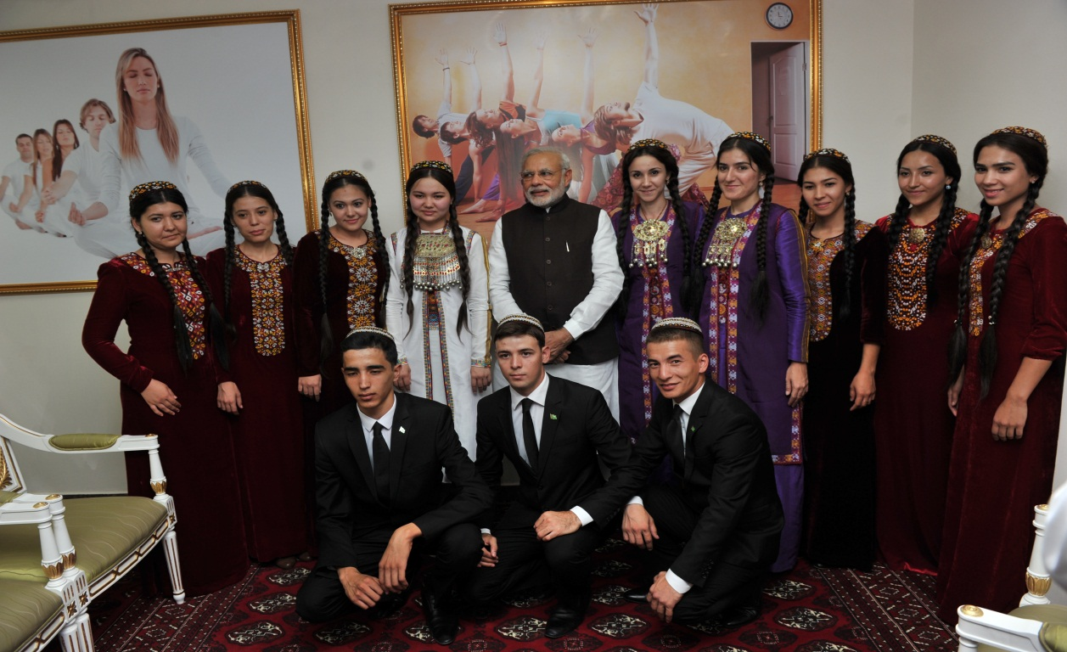
PM with Turkmen students learning Hindi

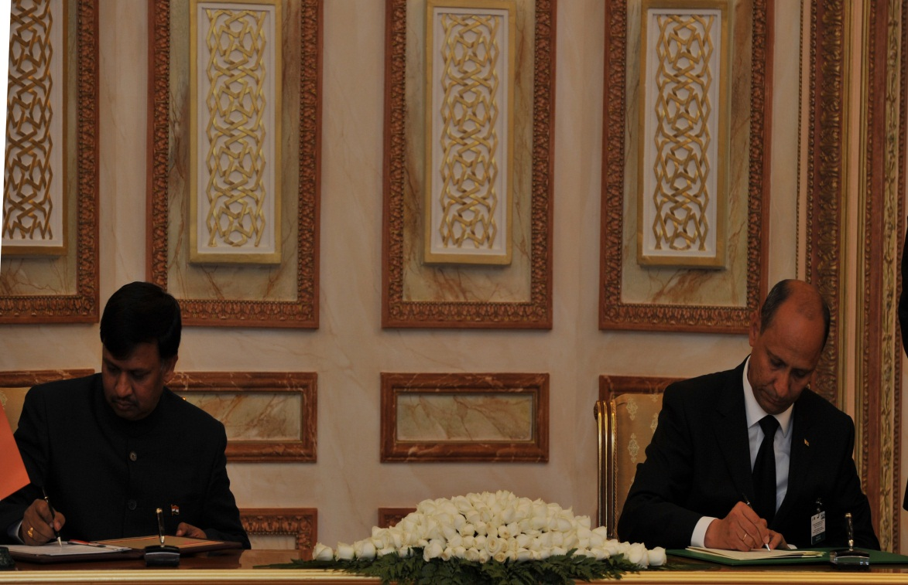
Ambassador Dr. T.V. Nagendra Prasad at the Signing ceremony

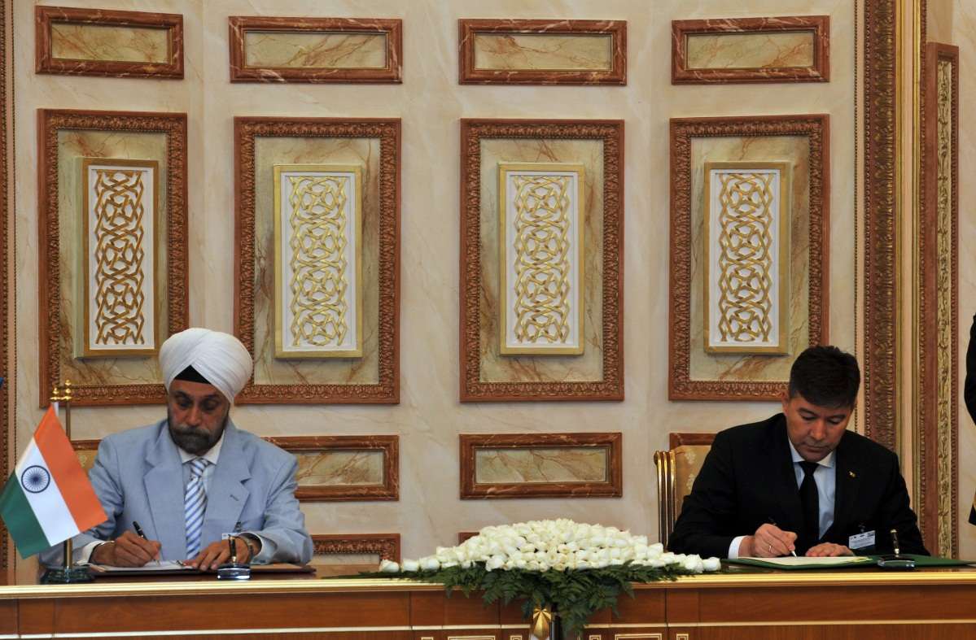
Shri Navtej S. Sarna, Secretary (West) at the Signing ceremony

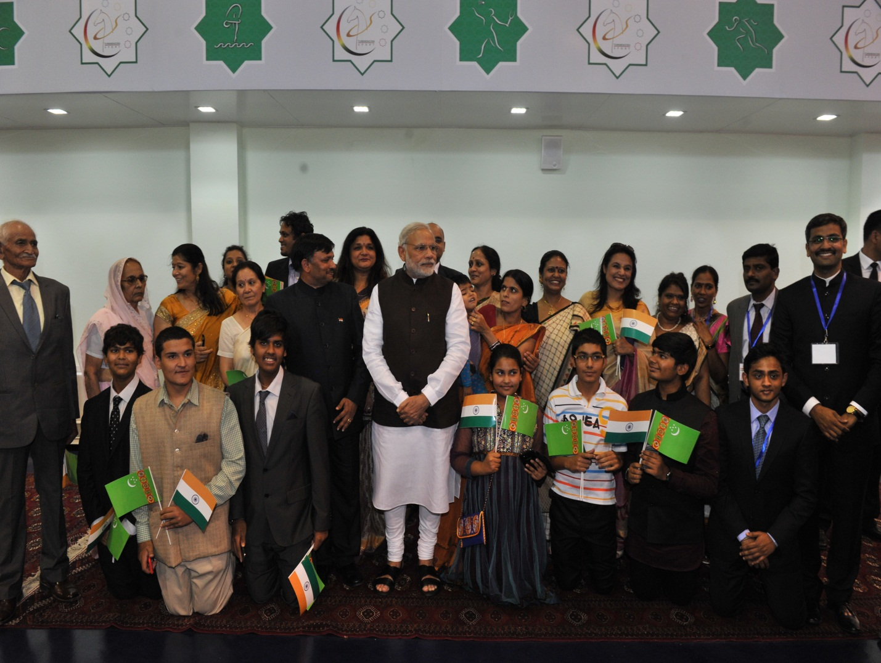
PM with Indian community
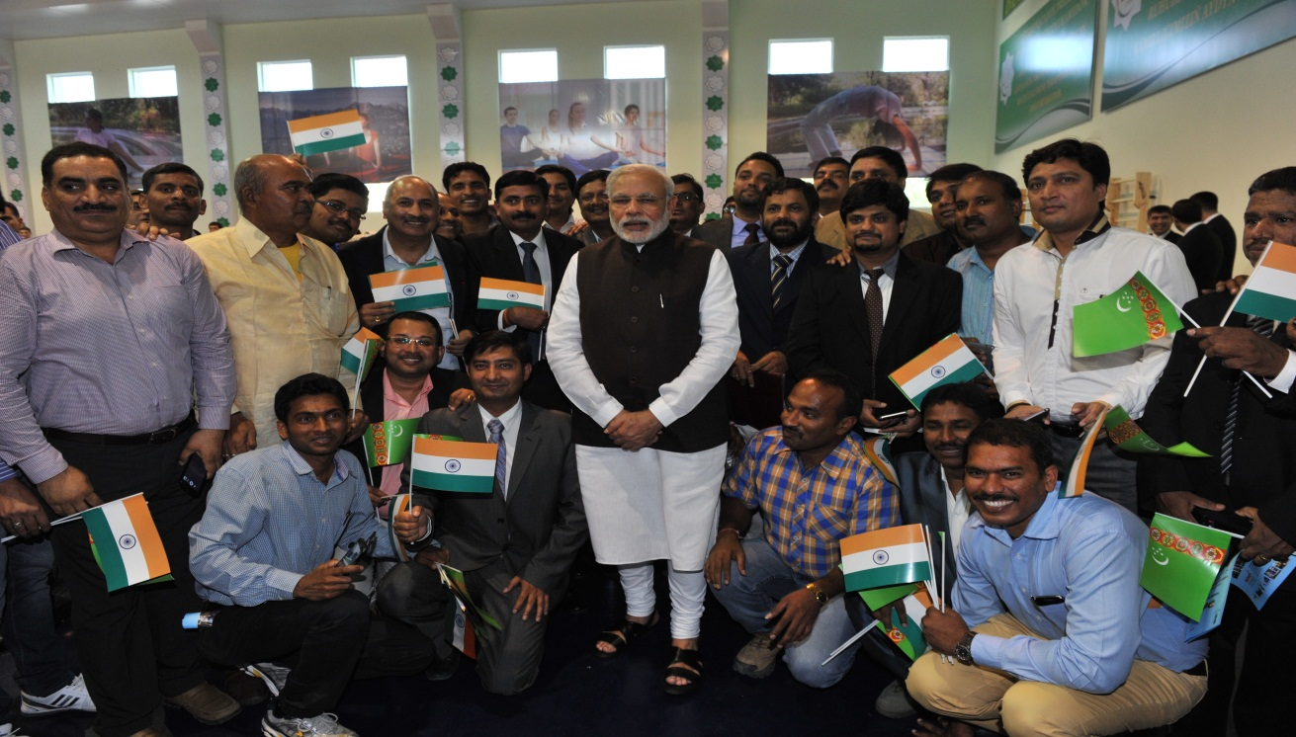
PM with Indian community in Ashgabat

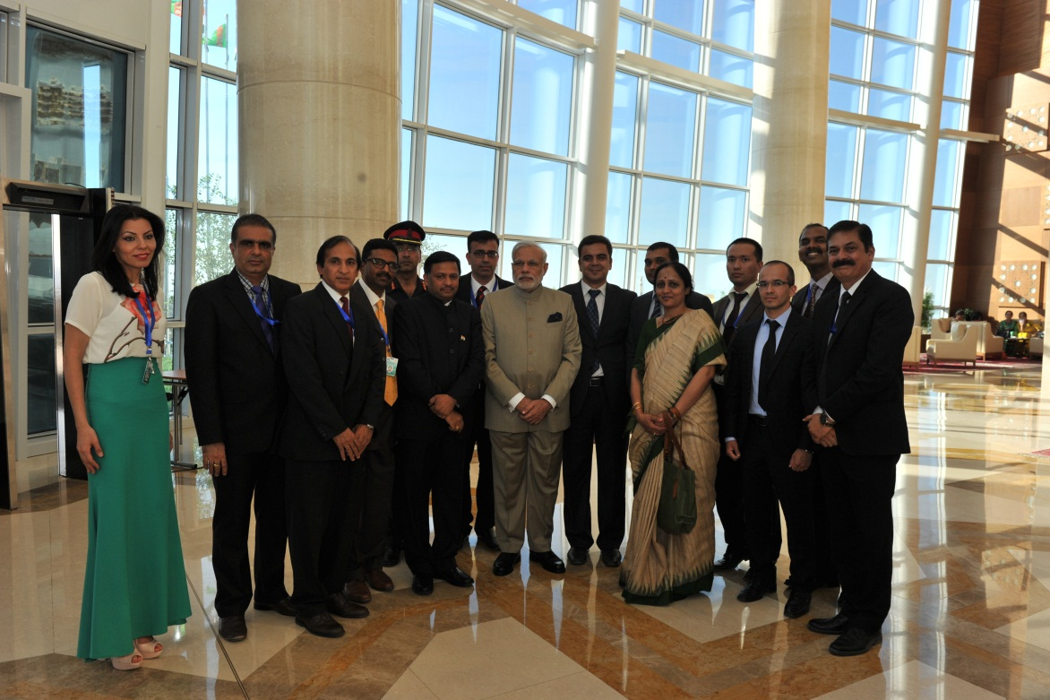
PM with Indian Embassy officials

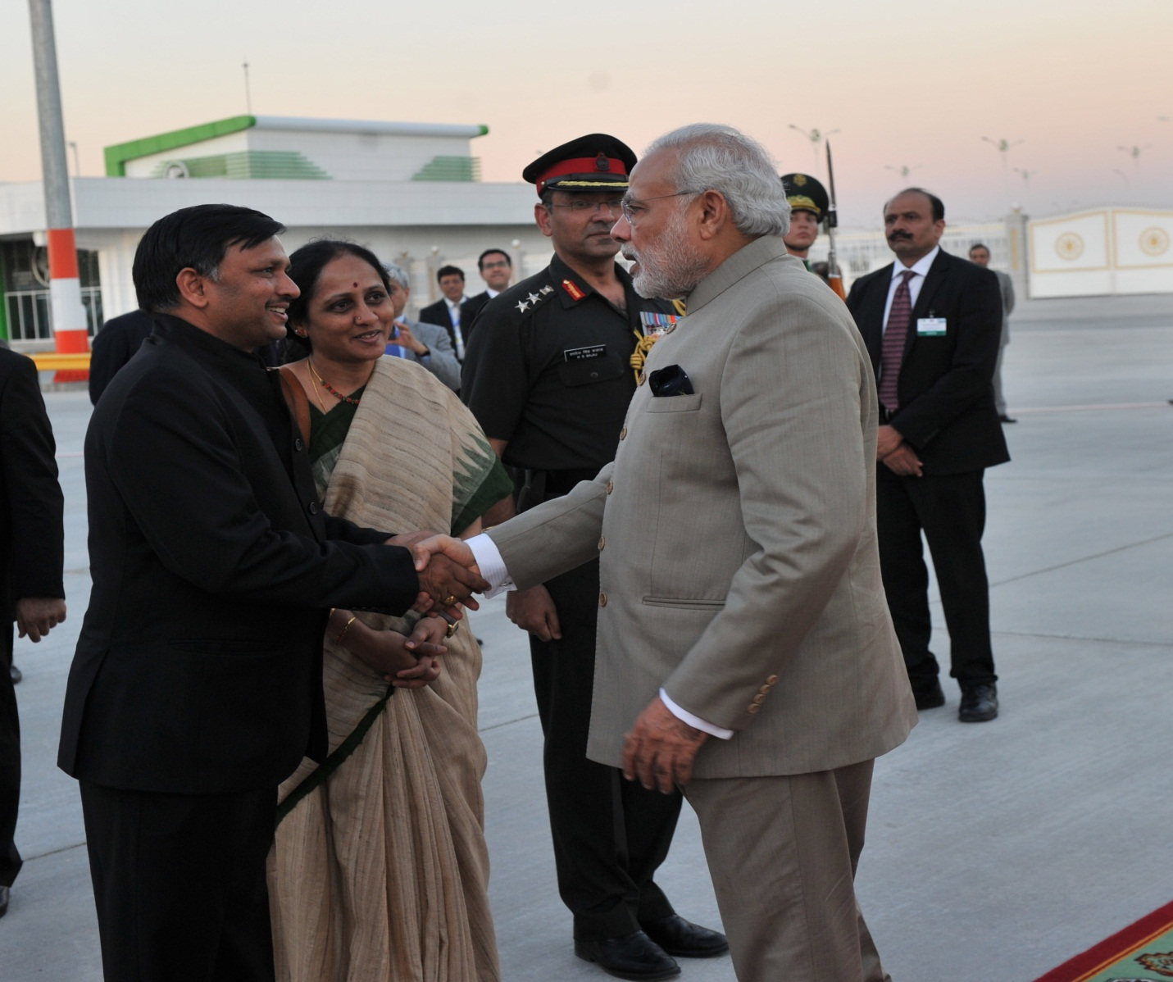

PM’s departure from Ashgabat

