
Embassy of India
Amman
Press Release
Sub: First International Day of Yoga celebrated in Jordan.
On 21th June 2015, the Embassy of India, under the patronage of HRH Princess Rym Ali of the Hashemite Kingdom of Jordan, in collaboration with the local Yoga partners successfully organized the first International Day of Yoga in Jordan.
2. The event started with a peace march titled as ‘Yoga for Peace and Harmony’ on the morning of historic day of 21st June. The march was conducted at the famous Zahraan Street of Amman. Various Jordanians and Indians participated with alacrity and exuberance.
3. Subsequently, the main event which was organized in the afternoon to celebrate International Day of Yoga in Jordan witnessed an overwhelming participation particularly by the Jordanians and various foreign diplomats. HRH Princess Rym Ali and HE Aqel Biltaji, the Lord Mayor of Amman were the ‘Honored Guests’ at the event.
4. The programme included Photographic and Yoga books exhibitions which were inaugurated by HRH Princess Rym Ali. Also demonstrations depicting various forms of Yoga viz. Ashtanga, Bali method of Yoga, Yin, Kundalini, Guided Prana Yana, Yamas & Niyamas and Acro Yogas were organized by thirteen local Yoga partners.
5. Speaking at the event Ambassador Trigunayat briefed the audience about the significance of Yoga for the wellbeing of mankind. HRH Princess Rym Ali delivered a keynote speech especially focusing on benefits of yoga stating that "Yoga is not for Yogis only but for everyone". H.E. Mr. Aqel Biltaji, Hon’ble Mayor of the Greater Amman Municipality, too delivered speech on Yoga signifying the essence of Yoga that is incumbent and embedded in all major religions of the world. He underlined that it was apt for Yoga to be held during Ramadan.

6. The Embassy also felicitated Ms. Samira Dajani for her over three decades of valuable contribution in propagating the noble cause of Yoga in Jordan by presenting a ‘Plaque’ capturing IDY emblem.

7. Lastly, all the participants participated in various Yogic meditation exercises including the ‘Dhyana in Sambhavi Mudra’. Ambassador Trigunayat also expressed his gratitude to all the participants and the ‘Honored Guests’ for supporting the noble cause of Yoga.

Amman
June 22th, 2015

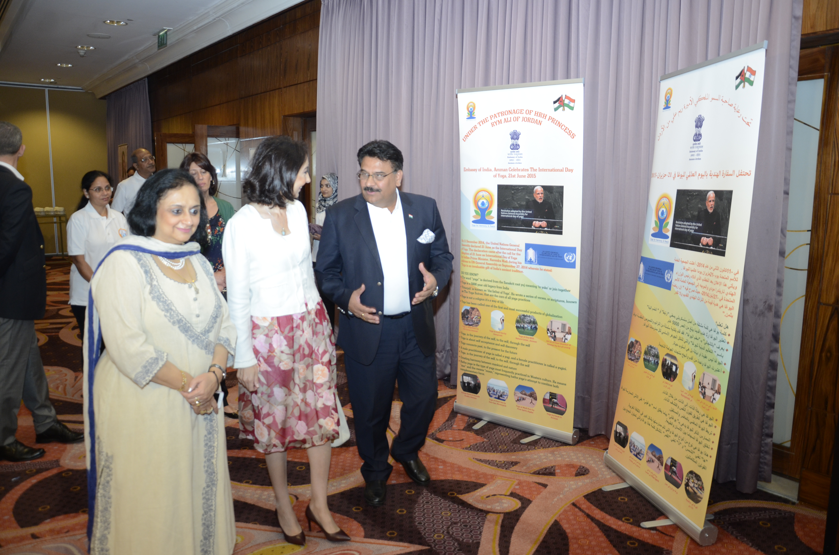
*(Pictures attached below)



