1st International Day of Yoga
Ashgabat
21 June 2015

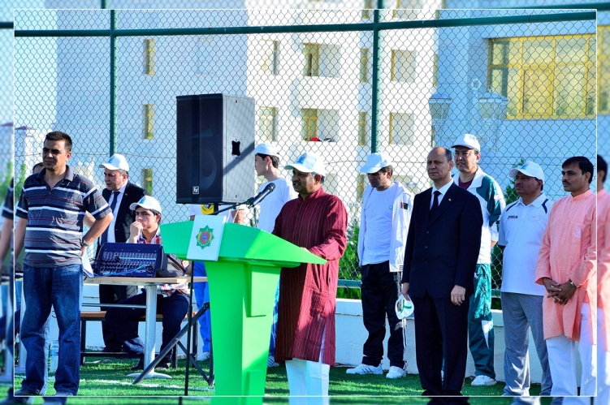
Ambassador of India Dr. T.V. Nagendra Prasad welcoming the Chief Guest
H.E. Mr. Amannepesov Nurmuhammet Kakabayevich,
Minister of Health Care & Medical Industry of Turkmenistan at the
1st International Day of Yoga

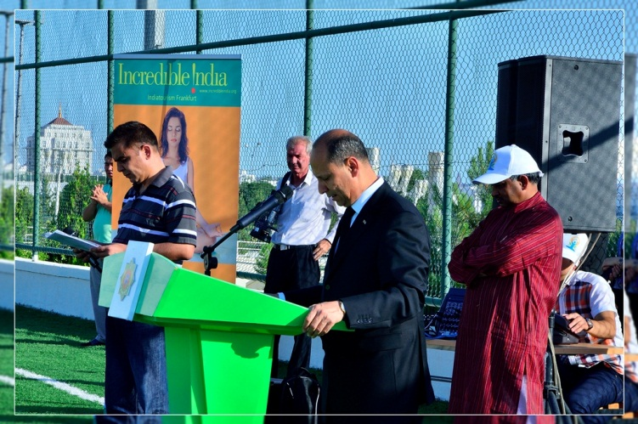
H.E. Mr. Amannepesov Nurmuhammet Kakabayevich,
Minister of Health Care & Medical Industry of Turkmenistan
addressing the participants at the 1st International Day of Yoga
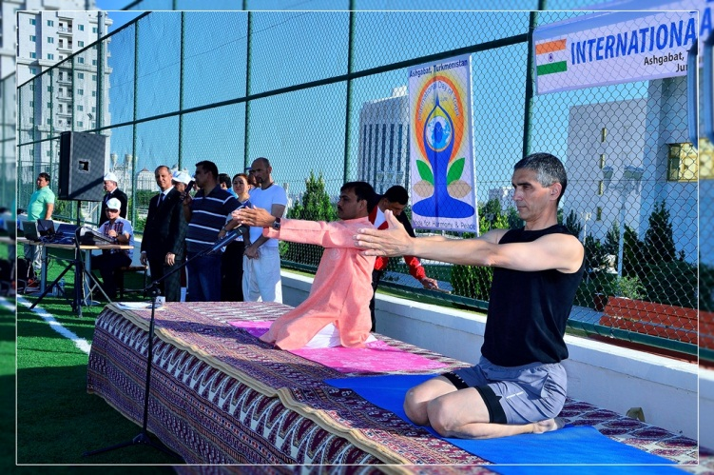
Yoga Teacher from India along with a local Yoga practitioner showing various yoga postures to the participants

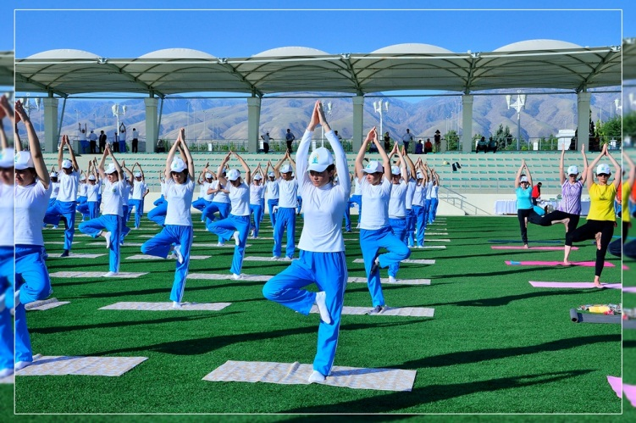
Participants doing Yoga postures

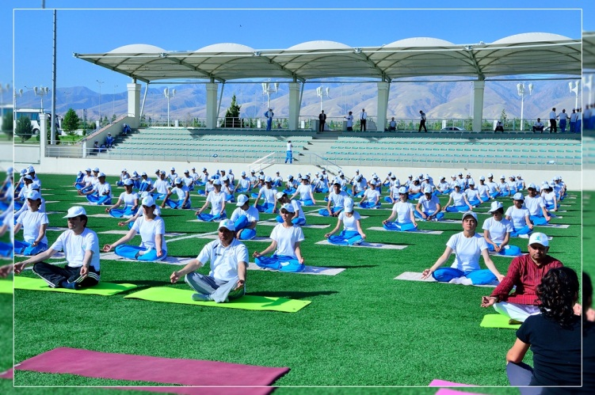

Chief of Protocol, MFA and other participants doing Dhyan Mudra

