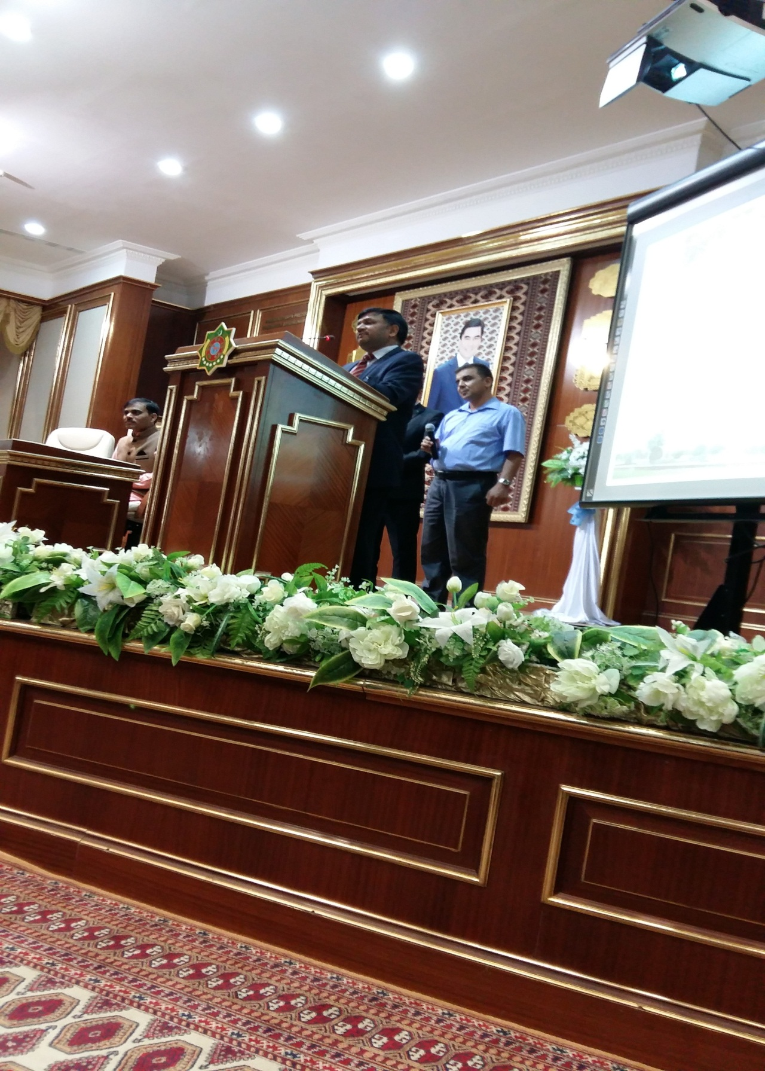
Ambassador addressing the students on Yoga on 16.6.2015 at the Medical University, Ashgabat

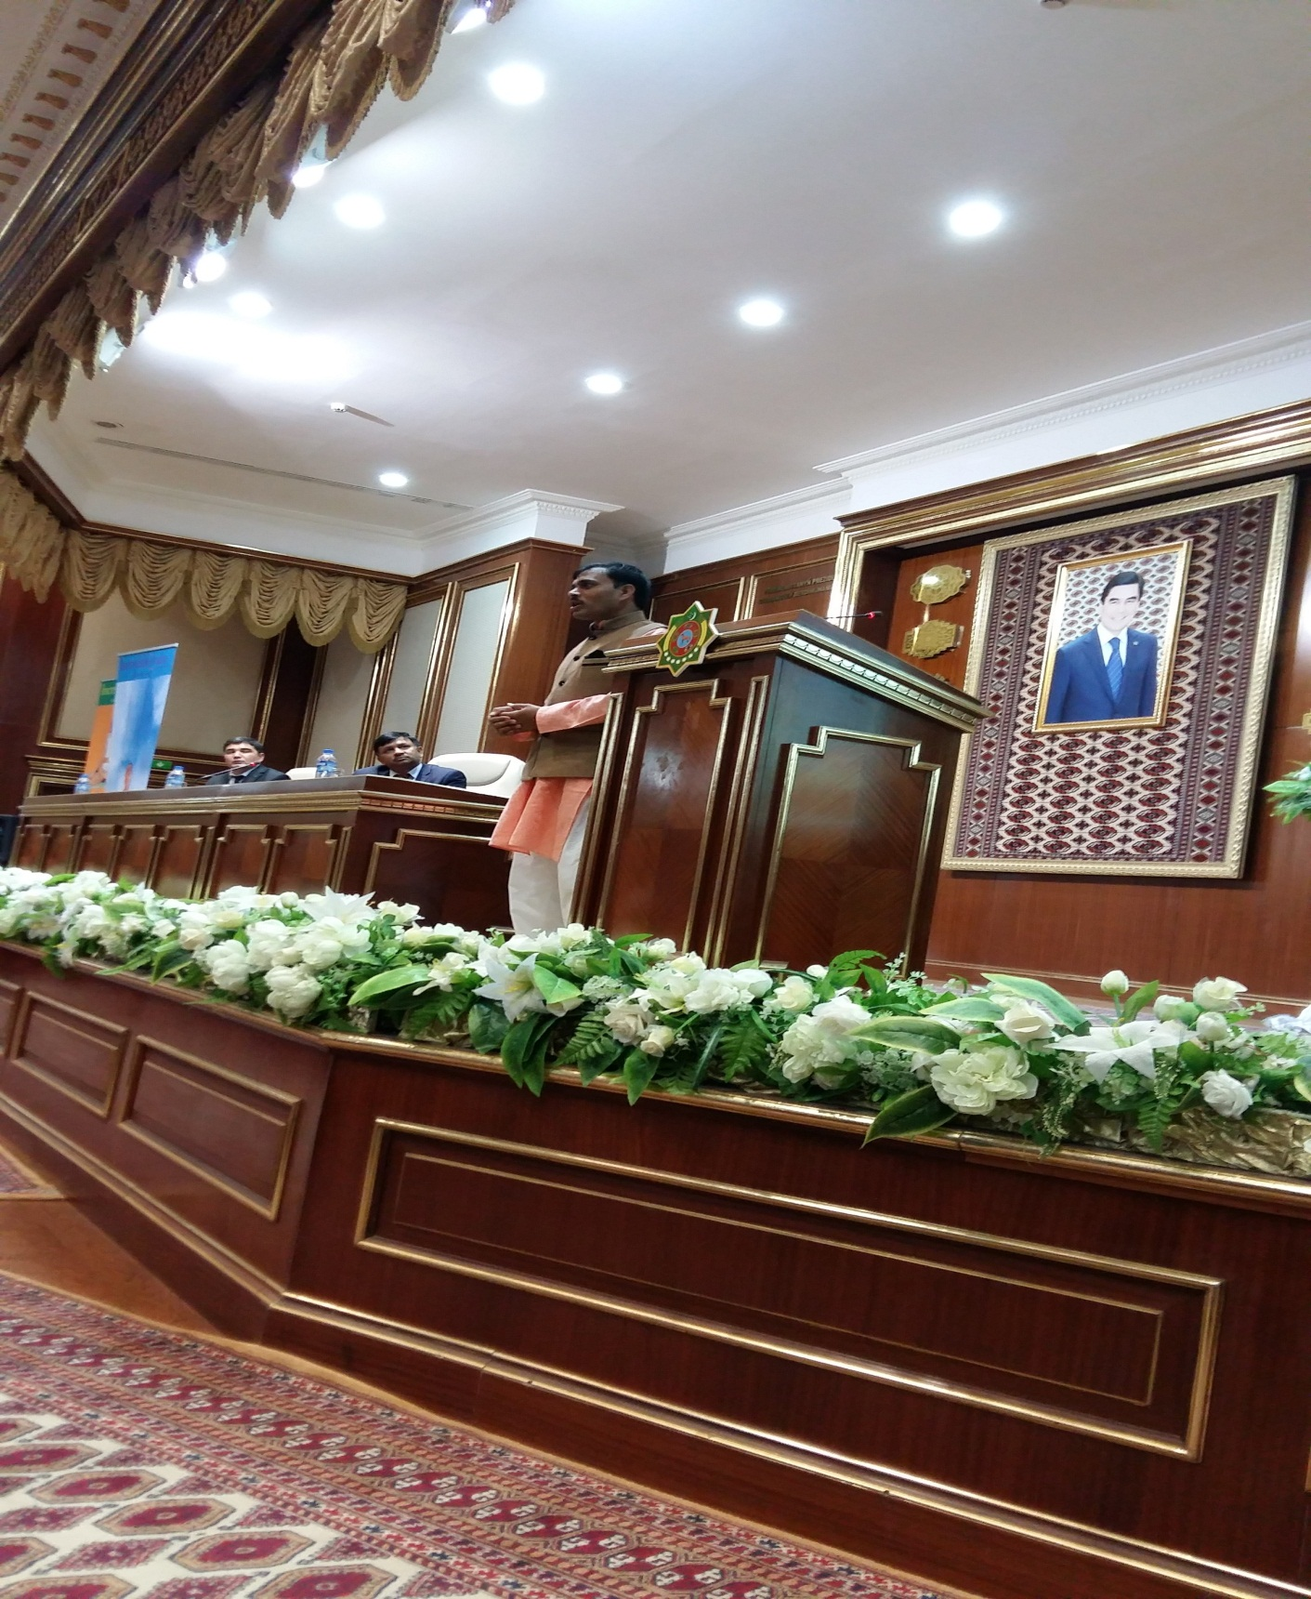
Yoga Guru addressing the students on 16.6.2015 at the Medical University, Ashgabat

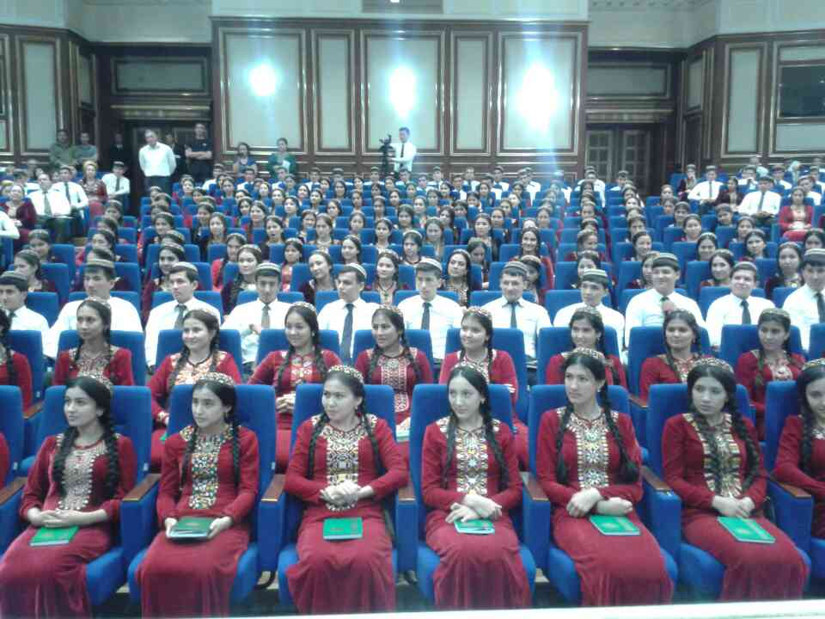

Students gathered at the Yoga lecture on 16.6.2015 at the Medical University

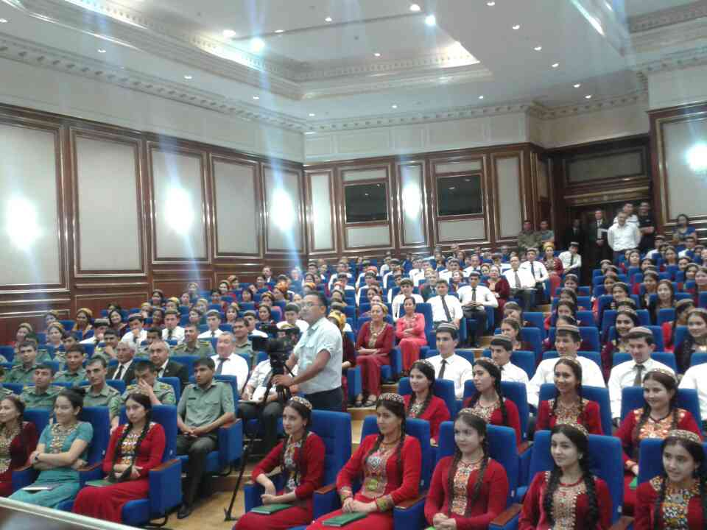
A view of students gathered at the Yoga lecture on 16.6.2015 at the Medical University, Ashgabat

