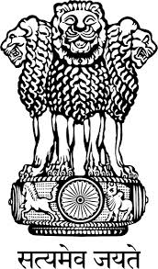
Embassy of India
Belgrade
Press Release

Serbia awards India’s “Katkatha”

The “Katkatha” Puppet Group from India has been awarded the “Group Award for the Best Puppet Animation” and “Award for best Director and Preservation of Tradition” for their performance ‘About Ram’ at the 22nd International Festival of Children’s Theatres in Subotica on 19th May, 2015. Last year, the Indian Puppet Group (Vinod Bhatt & Group) had won the “Best Animation” Award in the competition section of the Festival.
The Group also gave performances at the CNESA Cultural Centre, Kanjiza on 20th May; Youth Theatre, Novi Sad on 21st May; Zvezdara Theatre, Zvezdara on 22nd May and at “Pinokio” Theatre, New Belgrade on 23rd May, 2015 to full houses of audience. Their performances were highly appreciated by the Serbian public.

Katkatha’s “About Ram” is an experimental theatrical piece using excerpts from the Bhavbhuti Ramayana and told through animation, projected images, dance, masks and puppets. As the name suggests, the performance is about Ram the Prince exiled by his father along with his wife Sita and brother Lakshman. During their sojourn, Sita is kidnapped by Ravan, the King of Lanka. In this journey and the war that follows with Ravan, Ram became a king, forced to choose between the duty of the throne and the love of his life. He rules alone for the next 10,000 years.

Belgrade
May 25, 2015
***

