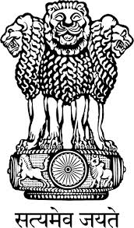

Embassy of India
Belgrade
Press Release
Indian agri-machinery companies participate in
Novi Sad Agricultural Fair 2015, Serbia
The 82nd International Agricultural Fair being held from 09-15th of May 2015, in Novi Sad, Serbia, is the largest agribusiness event in Serbia and one of the largest of its kind in Central Eastern Europe. The event has become a trademark and a prestigious place for presenting the latest products and achievements in the field of the agricultural Industry.
Several Indian companies are participating in this year’s event. This includes prominent agri-machinery companies, namely, Indian tractor manufacturers Mahindra & Mahindra (represented by Agropanonka), Sonalika (represented by FPM Agromehanika) and TAFE (represented by Amalgamations Group) which have displayed their products. Indian agri-machinery companies enjoy a fine reputation in Serbia and the Balkans. Indian company Mahindra & Mahindra and its Serbian partner M/s Agropanonka, donated Mahindra Tractor with Trolley and Mahindra Pickup Vehicle to the Mayor of Obrenovac to support the Municipality of Obrenovac in recovering from the disastrous effects of the catastrophic floods in May last year.
In addition, Indian irrigation equipment manufacturer Jain Irrigation is displaying its products through local company Agrogas. An Indian company Shreeji Protein has displayed food products such as dehydrated onion & garlic, peanuts, dry fruits and spices.
Belgrade
May 11th, 2015
***

