Permanent Mission of India, Geneva
Press Release
16 April 2015
India contributes US $ 100,000 to the International Trade Centre Trust Fund (ITC Trust Fund)
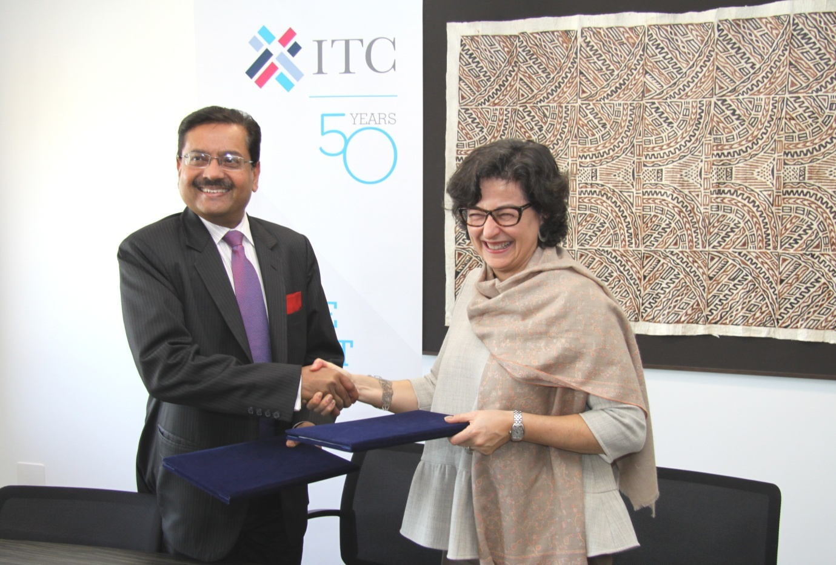
Ambassador and Permanent Representative of India to UN and other International Organisations, Mr. Ajit Kumar and Executive Director of ITC, Ms. Arancha Gonzalez signed an agreement on 15 April 2015 authorising ITC to use India’s contribution of US $ 100,000 to ITC Trust Fund for its Trade Related Technical Assistance (TARA) programme.
ITC is the technical cooperation agency of UNCTAD and WTO for operational and enterprise-oriented aspects of international trade development. It was created in 1964 through a decision of GATT contracting parties and in 1968 UNCTAD joined GATT as co-sponsor. ITC supports developing countries, particularly Least Developed Countries (LDCs), Land Locked Developing Countries (LLDCs), Small Island Developing States (SIDS), Sub- Saharan Africa, fragile states, small and vulnerable economies and economies in transition to develop Small and Medium Enterprise (SME) competitiveness through trade and international business development.
Ambassador Mr. Ajit Kumar briefed Ms. Arancha Gonzalez about the ‘Make in India’ campaign which is aimed to transform India into a world class manufacturing hub and explored possibility of ITC’s participation for value addition to this campaign. Both sides also discussed ITC’s SITA Project (Supporting Indian Trade and Investment for Africa) and expressed resolve to work closely to make this a successful model for south-south trade and investment cooperation project.
*****

