|  |  |
| --- | --- |
| http://www.indianconsulate-sf.org/images/ashokachkra.gif | EMBASSY OF INDIA  KUWAIT |

**Press Release**

Shapoorji Pallonji & Co. Ltd., Mumbai on 26 January 2015 signed a contract worth KD 150 million (about USD 513 million) with Kuwait University (KU), Kuwait for Construction, Operation and Maintenance of the buildings of Colleges of Law, Social Sciences and Sharia and Islamic Studies in the Sabah Al-Salem University City. Shapoorji Pallonji operates in Kuwait with its local Joint Venture partner Al-Sager Trading & Contracting Company since January 2011.

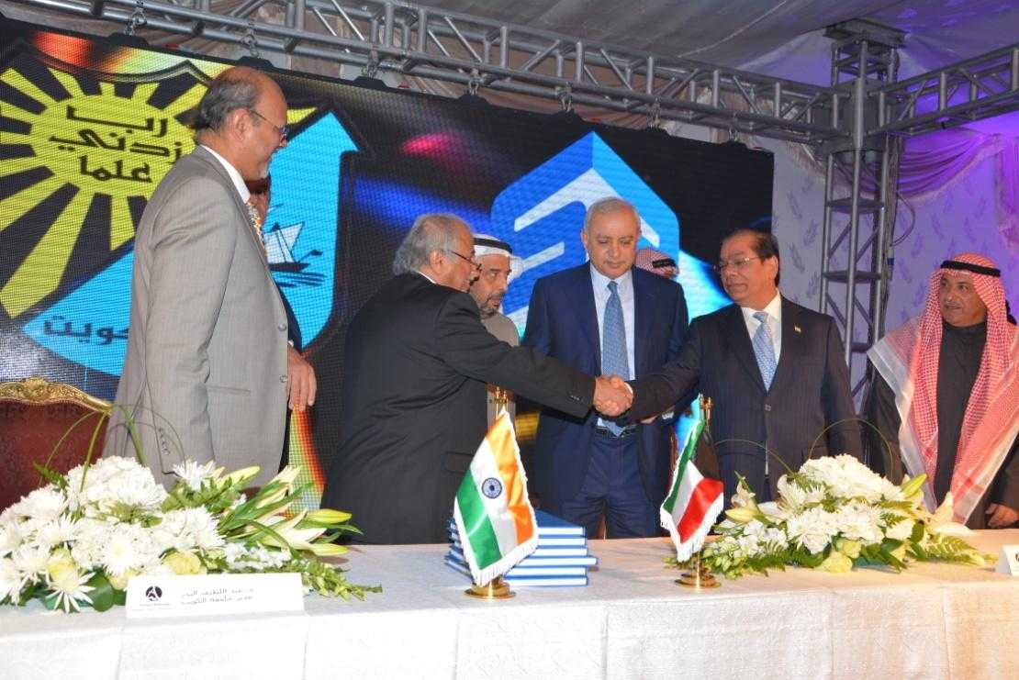

2. The signing ceremony was attended by H.E. Dr. Bader Hamad Al-Essa, Minister of Education and Minister of Higher Education of the State of Kuwait; Dr. Abdullatif Al-Bader, Director of Kuwait University; Dr. Qutaiba Abdul-Razzaq Razouki, Director of Kuwait University Construction Program (KUCP); Mr. Mohan Dass Saini, Managing Director & CEO, Shapoorji Pallonji International; Mr. Aroon Sen, Country Head, Shapoorji Pallonji, Kuwait and Mohd. Yusuf Al-Sager, Chairman, Al Sager General Trading & Contracting Co., Kuwait.

3. H.E. Dr. Bader Hamad Al-Essa said that “the contract, which will be completed within four years, constitutes a big step towards the completion of the city project, since the Sabah Al-Salem University City is part of Kuwait's Development Plan.”



**28 January 2015**