Sincere political friendship between Serbia, India
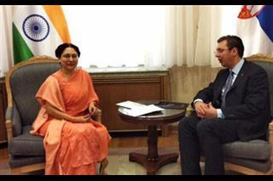
BELGRADE - Serbian Prime Minister Aleksandar Vucic and Indian Ambassador Narinder Chauhan noted Thursday that relations between Serbia and India are at the level of mutual respect, trust and sincere political friendship.
Ambassador Chauhan thanked the Serbian government for visa liberalization implemented for Indian nationals, Serbia's media relations office released.
The two officials also discussed ways to promote economic cooperation, stressing that India and Serbia have big plans together concerning modern technologies, defense industry, healthcare and medicine.
Vucic and Chauhan agreed they will monitor the implementation of the two countries' economic plans on the weekly basis, the statement reads.

