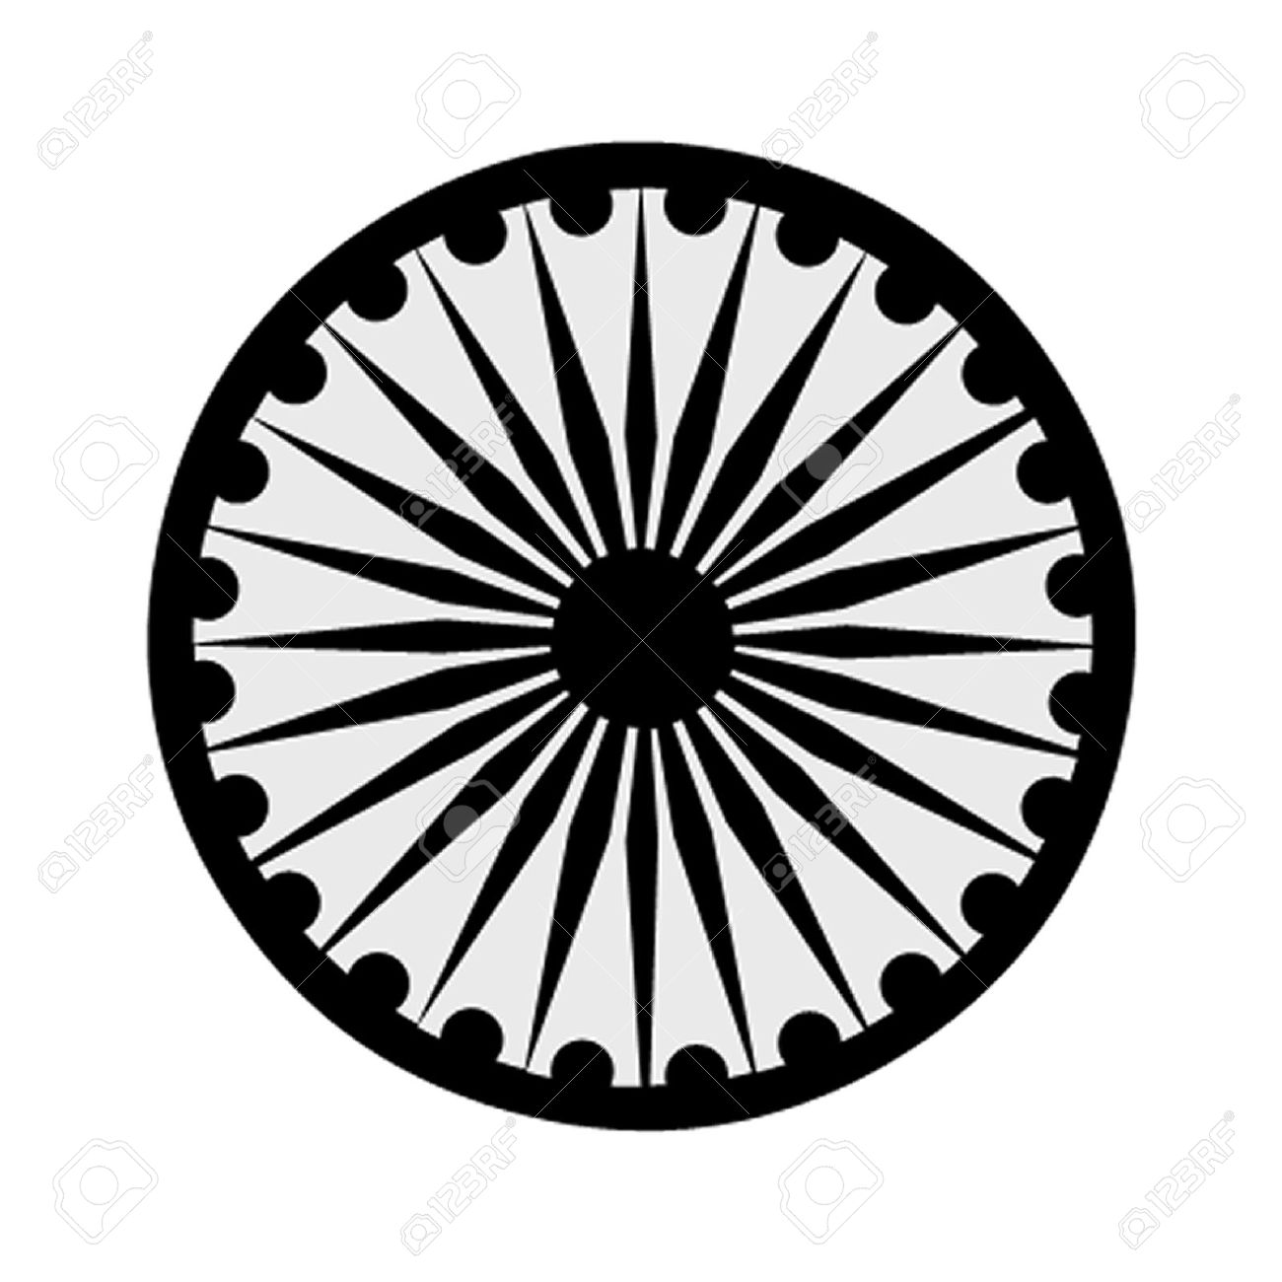 | HIGH COMMISSION OF INDIA, BRUNEI DARUSSALAM  P.O. BOX 439, LAPANGAN TERBANG LAMA  BANDAR SERI BEGAWAN BB 2339685  Telephone: 2339947 / 2339685  Fax: 2339783  E-mail: hoc.brunei@mea.gov.in  Website: www.hcindiabrunei.gov.in

Press Release No.02/2023

PRESS RELEASE
12th World Hindi Diwas celebrations in Brunei Darussalam

High Commission of India in Brunei Darussalam celebrated the 12th World Hindi Diwas 2023 on 17 February 2023, at India House, the official-residence of the High Commissioner of India to Brunei Darussalam.

2. Nearly one hundred and fifty Bruneian children, teachers, children of overseas-community, local-nationals, and Indian-diaspora members were present on the occasion.

3. High Commissioner of India H.E. Alok A. Dimri, read out Hon’ble Prime Minister Shri Narendra Modi’s message delivered on the occasion. A quiz based on common Hindi and Malay words, similarities in both the languages, and cultural performances by school children were among the event-highlights.

4. In his welcome remarks, High Commissioner encouraged the guests and school children to learn and use Hindi in daily-lives and to inspire their friends as well. He touched upon efforts towards spreading awareness about Hindi on the global-stage and shared highlights from the World Hindi Conference in Fiji. The High Commissioner also spoke of the ‘International Year of Millets-2023’ and its attendant health-benefits. Appreciation-gifts to children were presented on the occasion.
****

17 February 2023
Brunei Darussalam

