High Commission of India
Abuja
***
Celebration of Indian Technical and Economic Cooperation (ITEC) Day 2019

The High Commission of India celebrated the Indian Technical and Economic Cooperation (ITEC) Day on 17 January 2019. Hon’ble Minister for Communications of Nigeria, H.E. Dr. Adebayo Shittu and the Deputy Director (Bilateral Economic Cooperation), Ministry of Budget and National Planning, Mr. Simon Iluema, who was representing Hon’ble Minister for Budget and National Planning of Nigeria H.E. Sen. Udoma Udo Udoma, were welcomed by High Commissioner of India Shri Abhay Thakur. Nearly 250 ITEC alumni, Indian community and Nigerian friends of India, attended the event.
2. Hon’ble Minister for Communications of Nigeria, H.E. Dr. Adebayo Shittu praised the capacity building efforts of the Indian Government through fully funded training programmes, as well as Government of India’s readiness to support Nigeria in IT-related projects such as the rural broad band connectivity network. High Commissioner of India called on Nigeria, Benin, Cameroon and Chad to fully utilize the ITEC slots so that the same can be increased next year. Two ITEC alumni, who have benefited from the ITEC Programme- Ms. Dorothy Esiri, Dy. Director, Centre for Management Development, Abuja and Mr. Ibrahim Umar Shelleng, Assistant Chief Technical Officer, Defence Industries Corporation of Nigeria, Kaduna shared their experiences of the ITEC programmes they had attended in India. They praised Government of India for the opportunity and reiterated how their experiences helped the organizations with which they are working.
3. On this occasion, Hon’ble Minister for Communications of Nigeria and the High Commissioner of India presented the book, ‘EXAM WARRIORS’, written by Hon’ble Prime Minister of India, to the audience. The event also had a cultural segment with dance performances by a dance group from the Indian Cultural Association in Abuja and a Nigerian dance group from Kano.

18 January 2019
Abuja

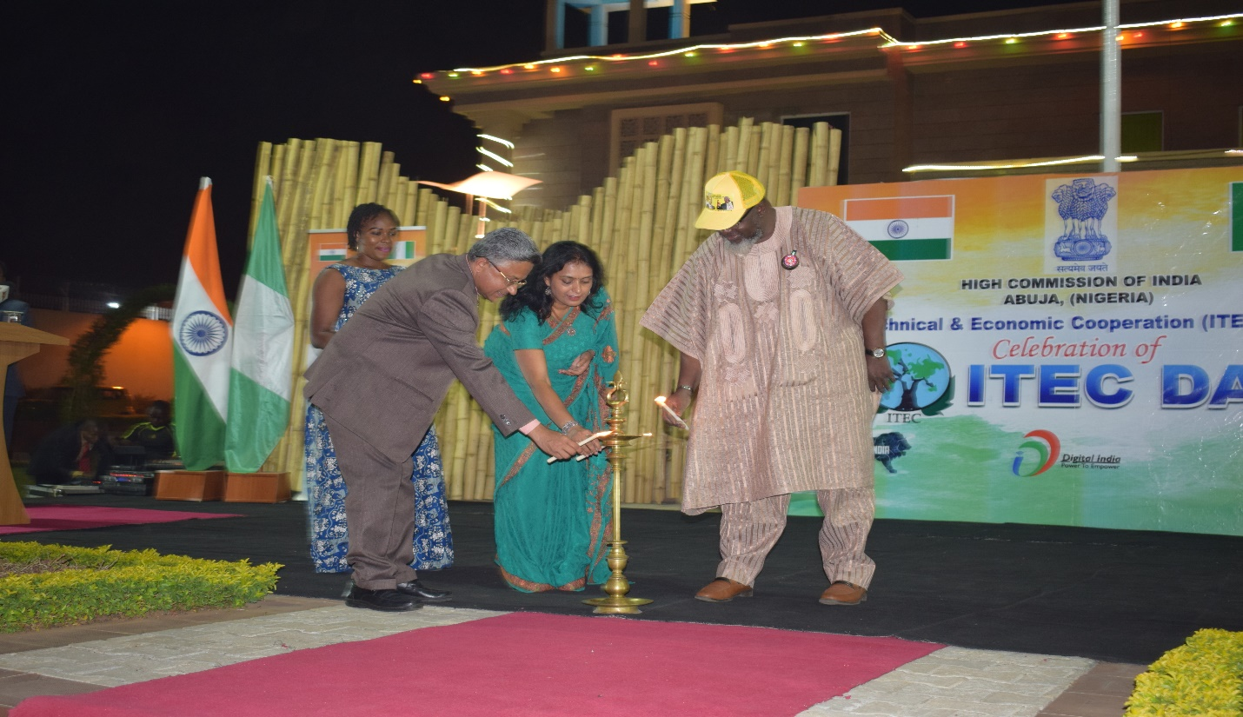
Hon’ble Minister for Communications of Nigeria, H.E. Dr. Adebayo Shittu, H.E. Mr. Abhay Thakur, High Commissioner of India to Nigeria and Dr. Surabhi Thakur inaugurating the ITEC Day celebrations by lighting the lamp.
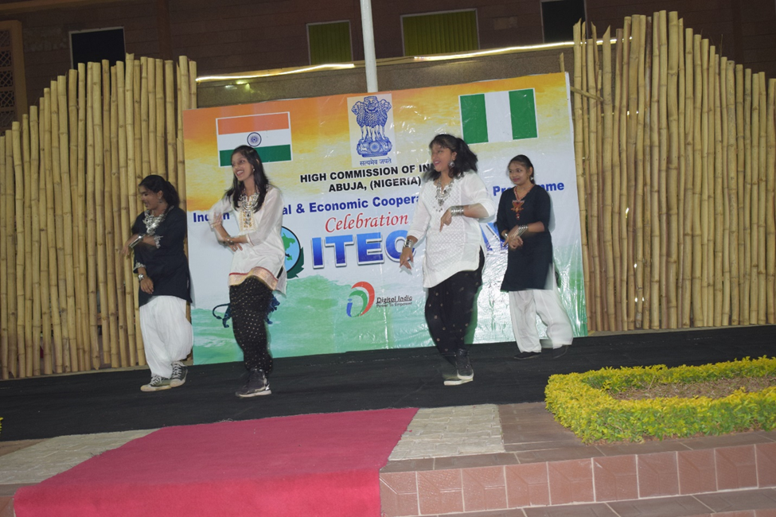
Children from the Indian Community in Abuja performing dance during the cultural segment of ITEC Day celebrations.
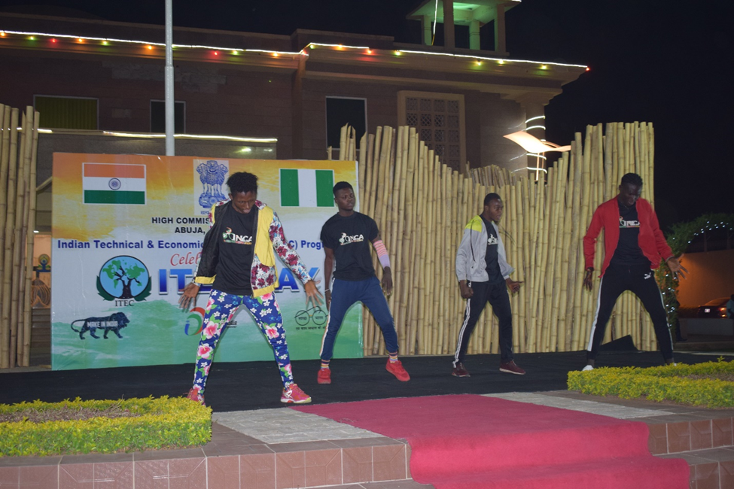
Nigerian dance group from kano performing during the cultural segment of ITEC day celebrations.
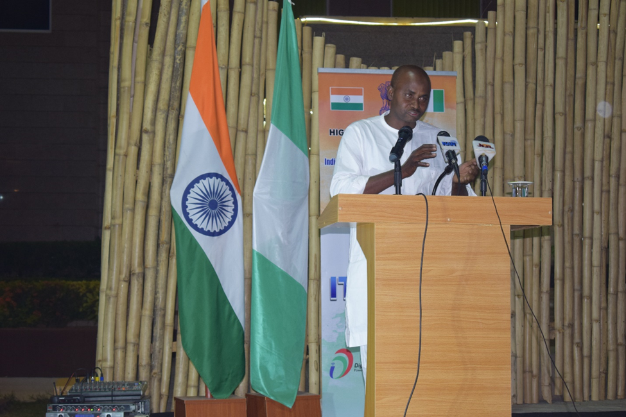
Mr Ibrahim Umar Shelleng, Assistant Chief Technical Officer, Defence Industries Corporation of Nigeria, Kaduna who availed “21st International Training Course on Wind Turbine Technology & Applications” under ITEC in 2018 sharing his experiences of the ITEC programme.

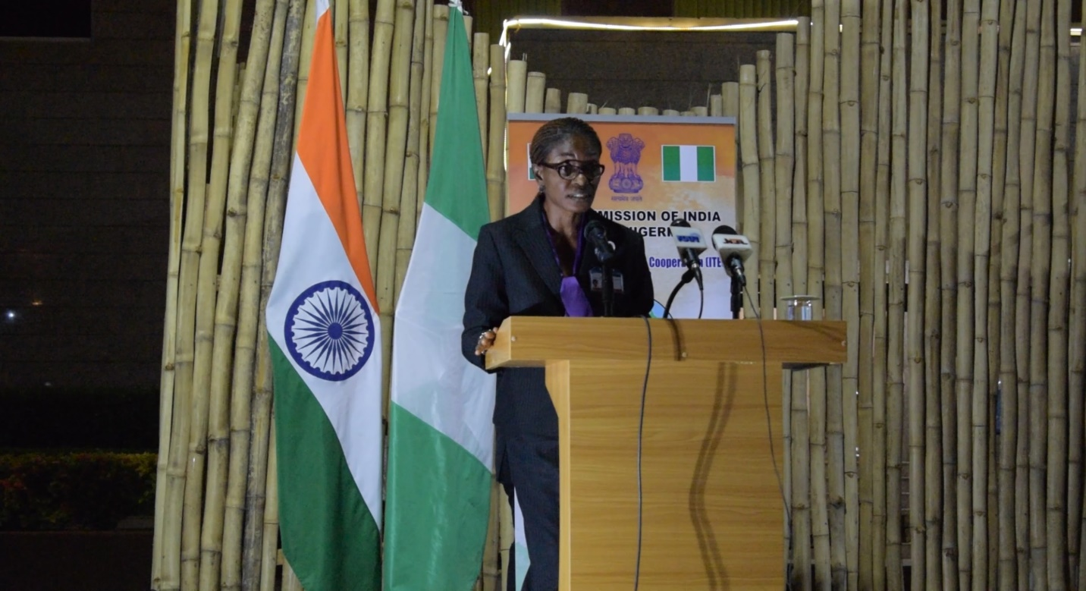
Ms Dorothy Esiri, Dy. Director, Centre for Management Development, Abuja, who has availed “Development Partnership: Learning South-South Cooperation” course under ITEC in 2018 sharing her experiences of the ITEC programme.
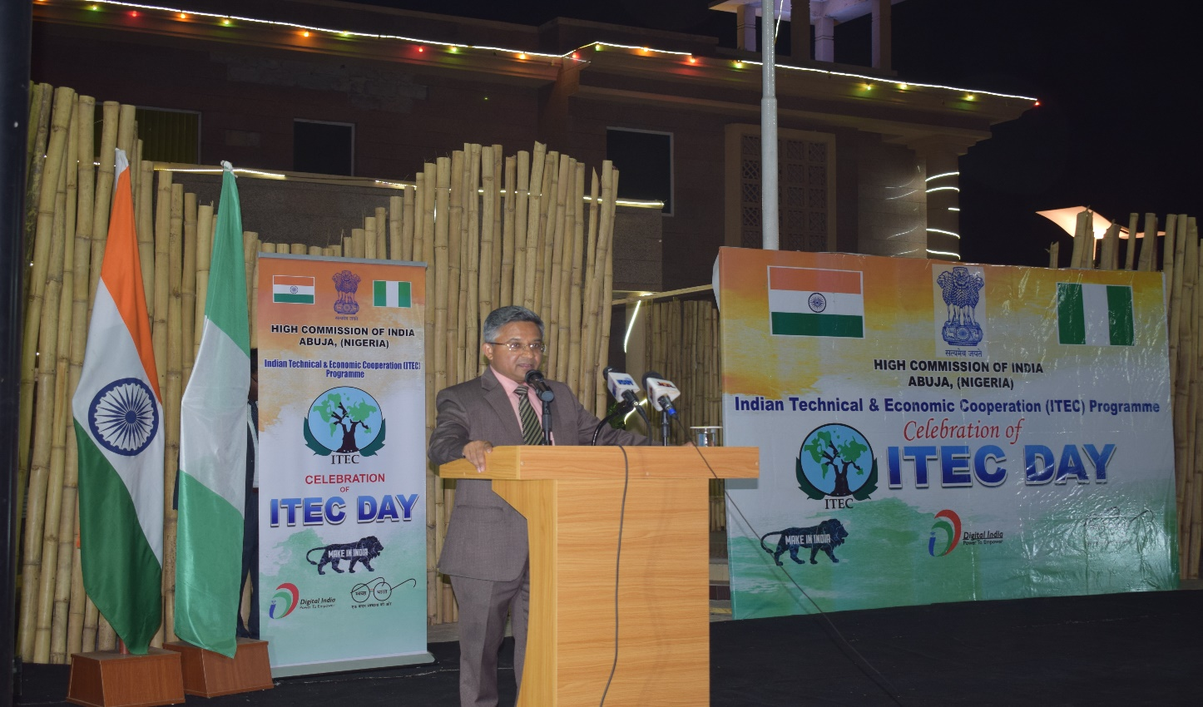
Shri Abhay Thakur, High Commissioner of India to Nigeria speaking about the capacity building efforts of the Government of India
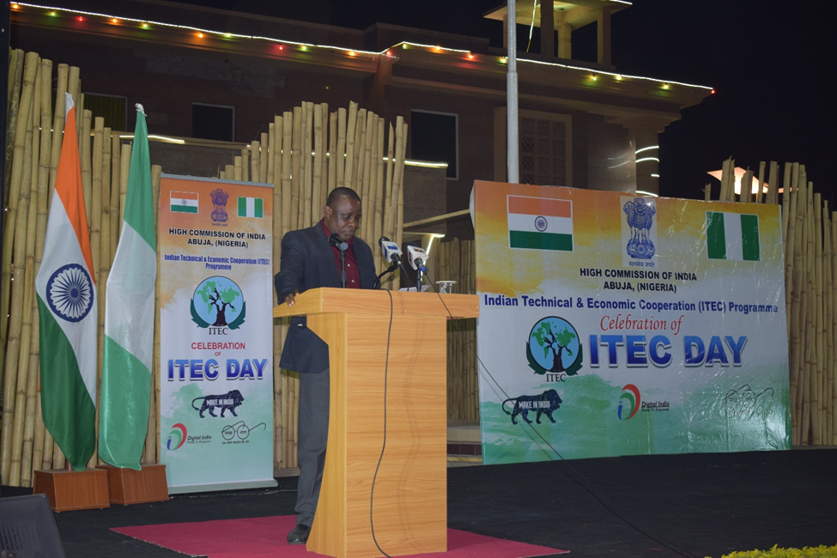
Mr. Simon Ileuma, Deputy Director (Bilateral Economic Cooperation) representative of the Hon’ble Minister of Budget and National planning of Nigeria H.E. Mr. Sen. Udoma Udo Udoma, appreciating India for the ITEC Programme.
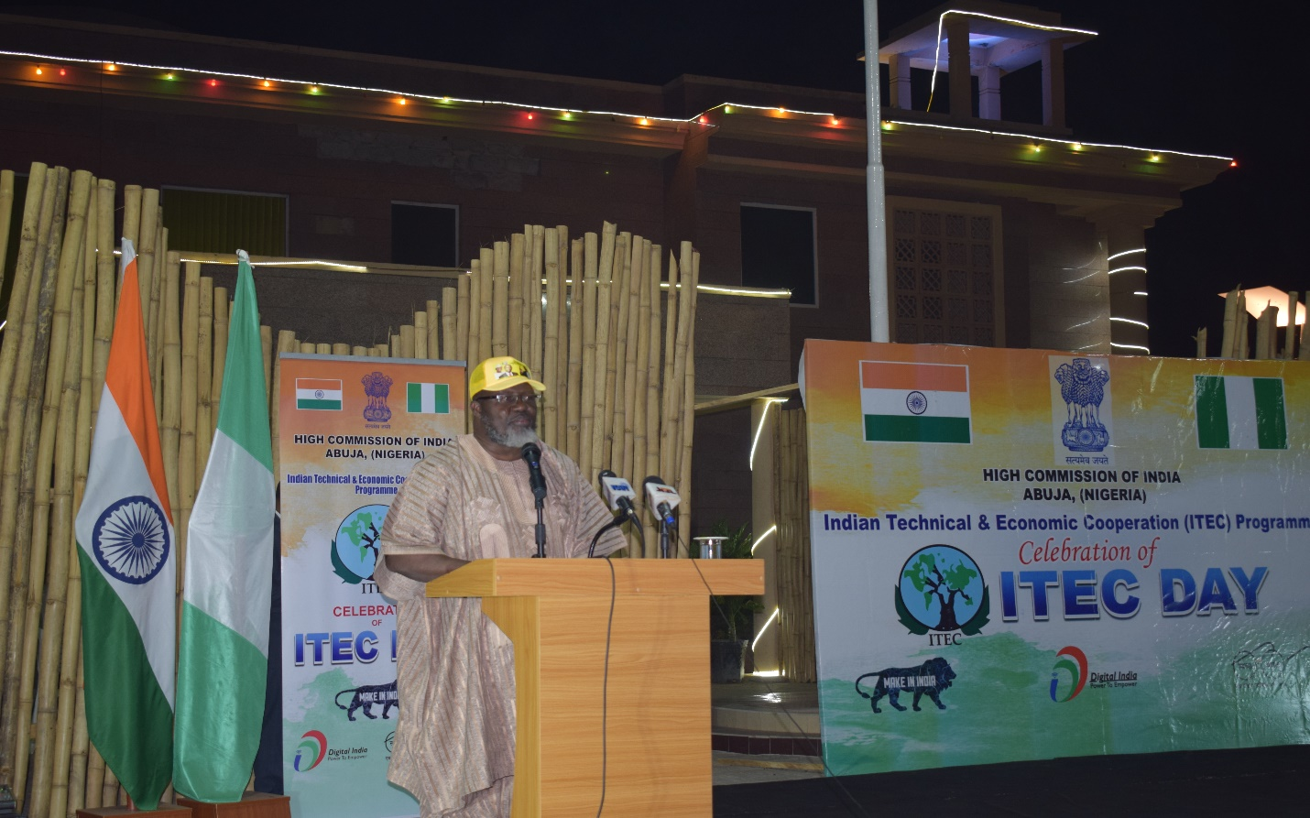
Hon’ble Minister for Communications of Nigeria, H.E. Dr. Adebayo Shittu, praising the capacity building efforts of the Indian Government through Lines of Credit and fully funded training programmes.

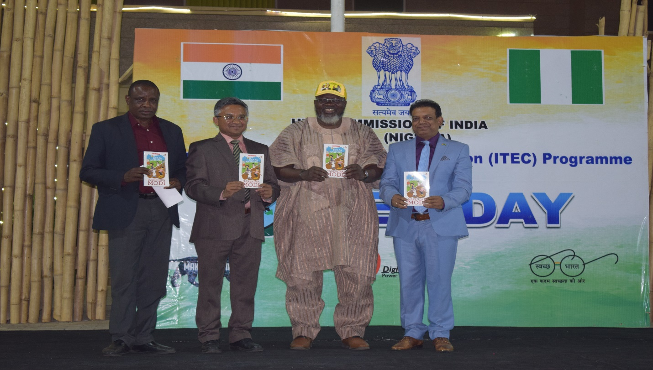
Hon’ble Prime Minister of India Shri Narendra Modi’s book titled ‘Exam Warriors’ was presented to the audience by Hon’ble Minister for Communications of Nigeria, High Commissioner of India, representative of Hon’ble Minister of Budget and National planning of Nigeria and Mr. Sanjay Srivastava, from AI Ticks Nigeria Pvt. Ltd.
*****

