High Commission of India
Abuja
***
Celebration of Pravasi Bharatiya Divas and World Hindi Day 2019

The High Commission of India celebrated the Pravasi Bharatiya Diwas and the World Hindi Day on 09 January 2019. Chief Robin Njoku, President of the All India Universities Alumni Association of Nigeria was welcomed by Shri Abhay Thakur, High Commissioner of India. Nearly 200 Indian diaspora, diplomats and Nigerian friends, attended the event.

2. High Commissioner of India read out the message of Hon’ble Prime Minister of India, Shri Narendra Modi on the Pravasi Bharatiya Diwas and spoke about further strengthening of bilateral relations between India and Nigeria, through priority areas of economic cooperation and developmental assistance. He hailed the Indian diaspora in Nigeria for contributing to the economic development of both Nigeria and India. Chief Robin Njoku spoke about his experiences in India during his University days in India, and Mr. K.P. Ray Chaudhary, former President of the Indian Cultural Association, Abuja spoke about the role played by Indian diaspora in Nigeria. Mr. Auwal Yusuf Konami from Dostana Association Kano and Mr. Ado Abdulkadir Yakasai, a local Nigerian singer spoke in Hindi about the importance of Hindi language and their affinity towards it.

3. The rendition of Mahatma Gandhi’s favourite Bhajan ‘Vaishnav Jan To’ by singers from Nigeria, Benin, Cameroon and Chad was screened, in addition to short film on the Pravasi Bharatiya Diwas and Kumbh Mela 2019. High Commissioner presented Letters of Appreciation signed by Smt. Sushma Swaraj, External Affairs Minister of India to the singers from Nigeria and Chad. Medals were awarded to the winners of the First Round of the ‘Bharat Ko Janiye’ Quiz, and trophies were presented to the winners of the Hindi competitions held on the occasion of the World Hindi Day.

10 January 2019

Abuja
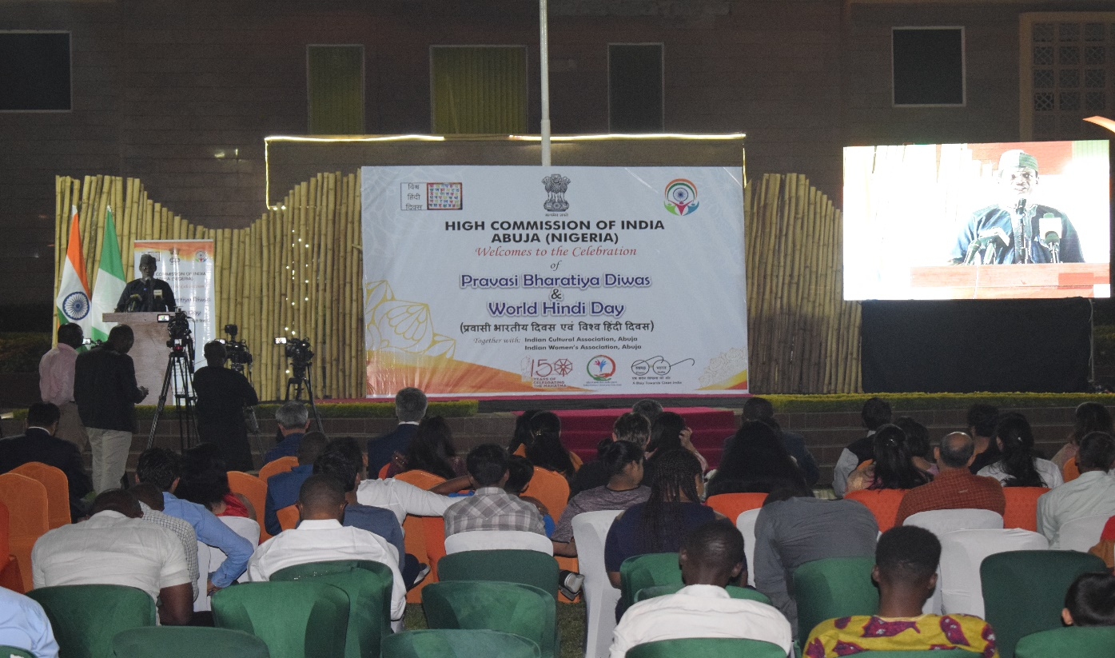
Mr. Auwal Yusuf from Dostana Association of Kano, speaking in Hindi on the importance of Hindi language.
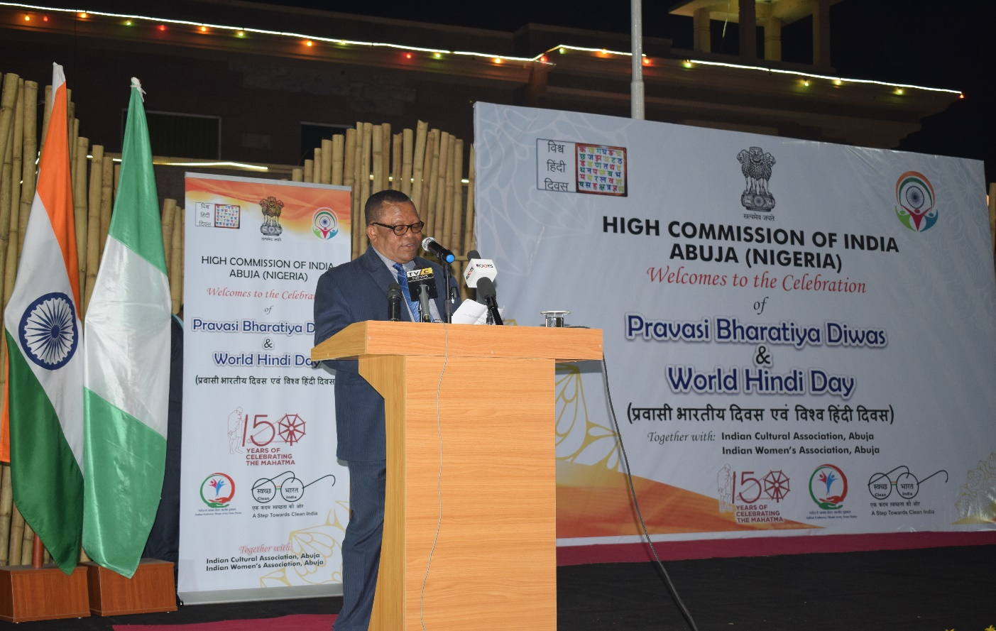
Chief Robin Njoku, President of the All India Universities Association of Nigeria, speaking on the Pravasi Bharatiya Diwas.
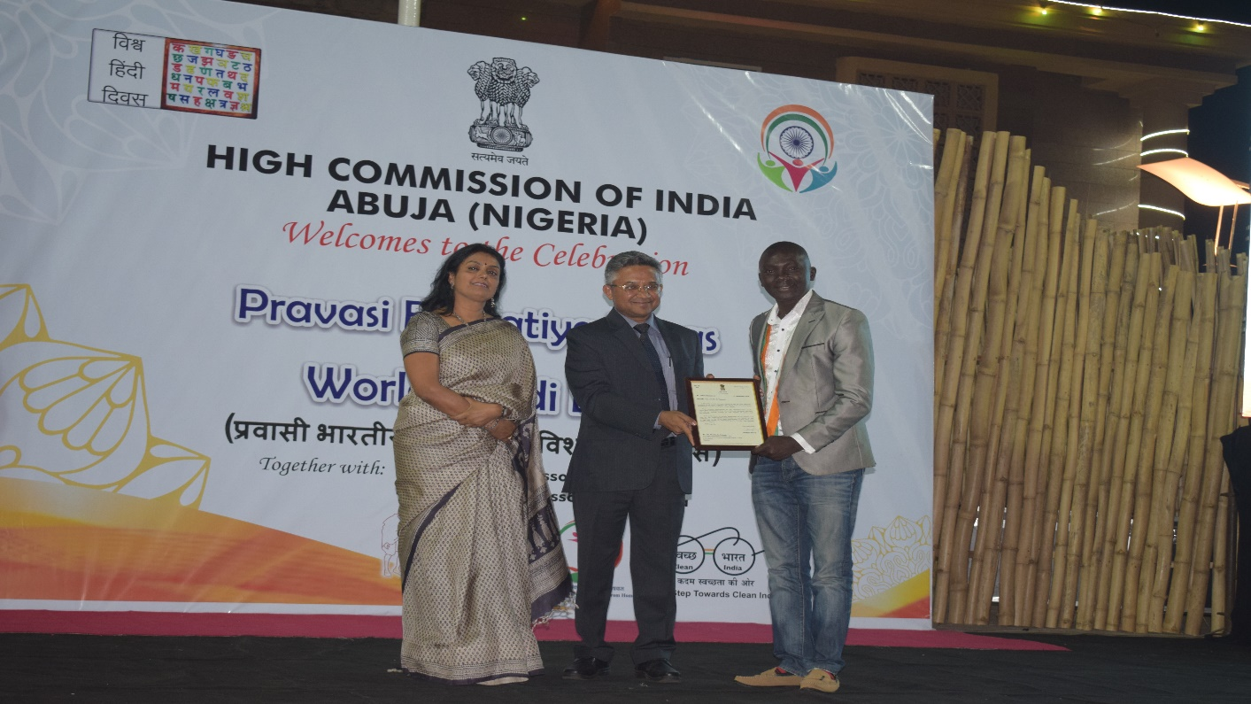
High Commissioner Shri Abhay Thakur presenting Letters of Appreciation signed by EAM Smt. Sushma Swaraj to the Nigerian singer Mr. Abdul for the rendition of Mahatma Gandhi ji’s favourite bhajan “Vaishnav Jan To”.
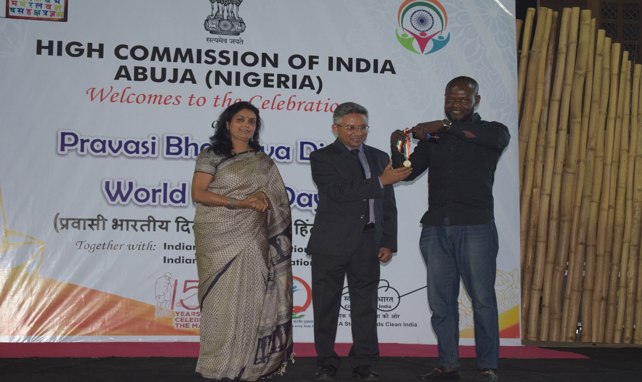
High Commissioner Shri Abhay Thakur and Dr. Surabhi Thakur presenting medals to the winners of the First Round of Bharat Ko Janiye (BKJ) Quiz.
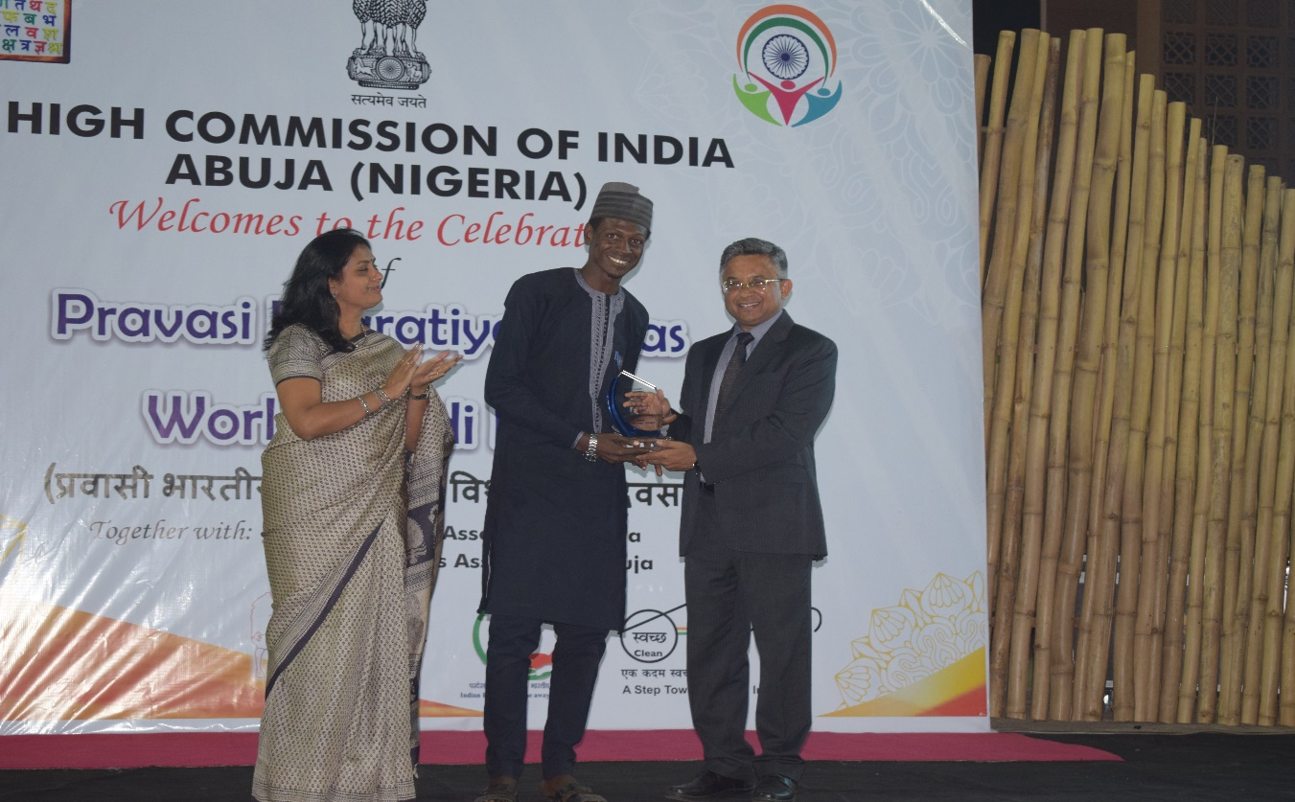
High Commissioner Shri Abhay Thakur and Dr. Surabhi Thakur presenting trophy to Mr. Auwal Yusuf, winner of the Hindi Competition held on the occasion of World Hindi Day.
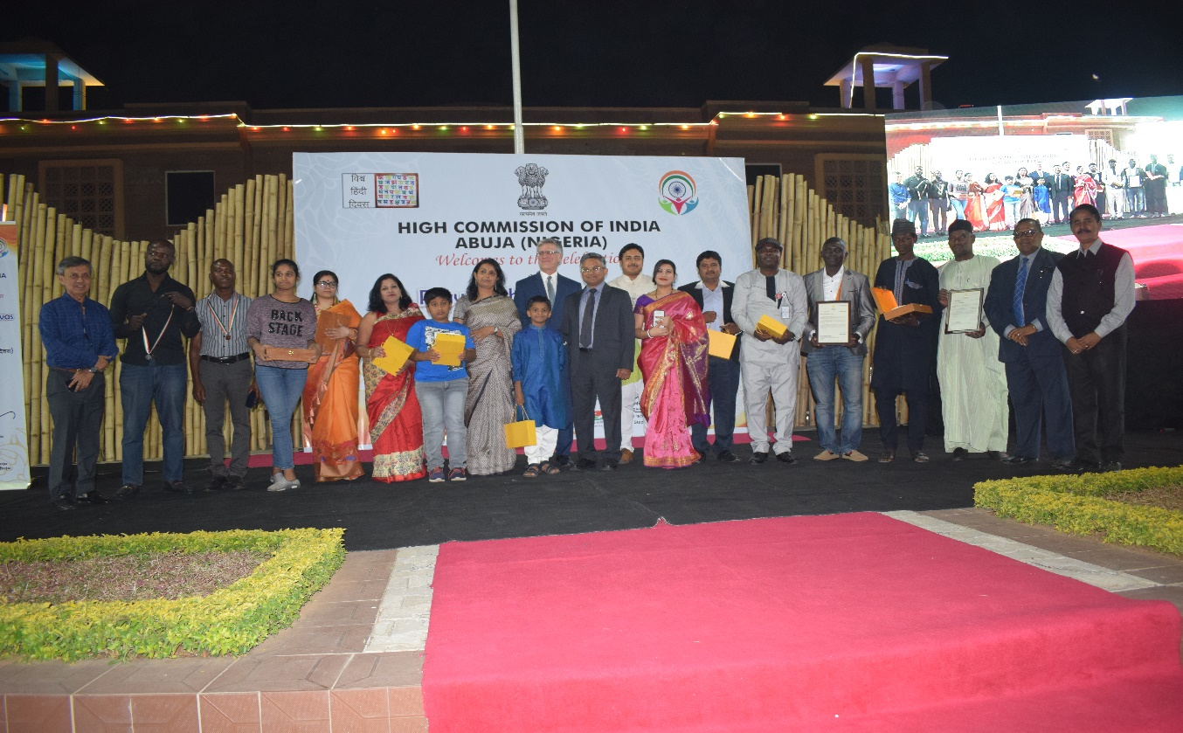
High Commissioner Shri Abhay Thakur with the winners of the Appreciation letters/ Medals/ Trophies, High Commissioner of Canada to Nigeria H.E. Mr. Philip Baker is also seen in the photo.
******

