Embassy of India
Dushanbe
……

On 18 December 2018, H.E. Mr. Shamsiddin Orumbekzoda, Hon’ble Minister of Culture and Mr. Numon Abdugafforzoda, Chairman of Tourism Development Committee (TDC), Republic of Tajikistan receive Shri Somnath Ghosh, Ambassador of India to Tajikistan at the International Festival of the Great Silk Road Hearritage under the theme ‘Rangorang’ at National Museum, Dushanbe.

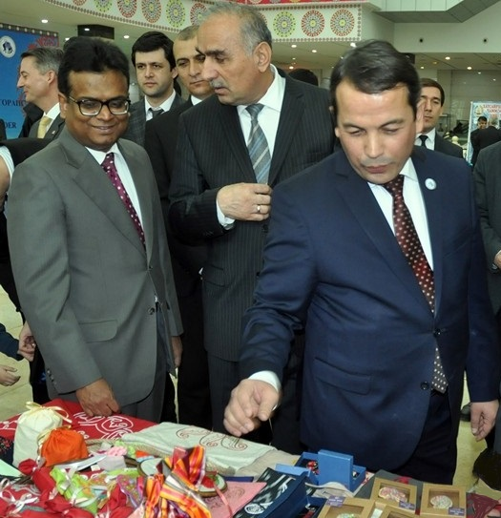
(From Right: Ambassador, Hon’ble Minister of Culture and Chairman TDC

