Embassy of India
Dushanbe
……

15th Lecture of the on going series title ‘Commemoration Lecture on India-Tajikistan: 25 years of Friendship’ jointly organized by Embassy of India in Dushanbe, Institute of Studies on Asian and European Countries and India-Tajikistan Friendship Society held on 27 November 2018 at Rahul Sankrityayan India Study Corner, Institute of Studies on Asian and European Countries, Academy of Science of the Republic of Tajikistan, Dushanbe. Dr. Shohzamon Rahmonov, Senior Member, Academy of Science, Rpublic of Tajikistan presented a paper on‘India through the eyes of Mirzo Tursunzoda’.

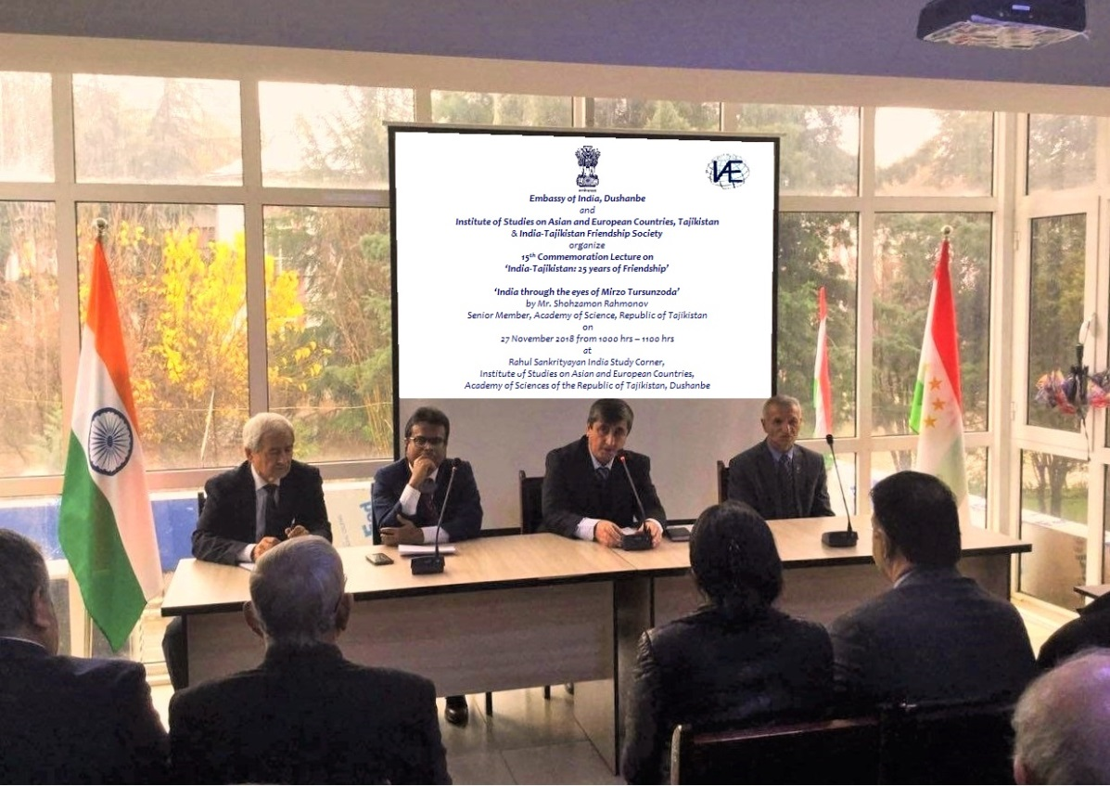
Mr. Yormahmad Niyozi Bobo, Director, Institute of Studies on Asian and European Countries, Academy of Science of the Republic of Tajikistan delivers welcome remarks
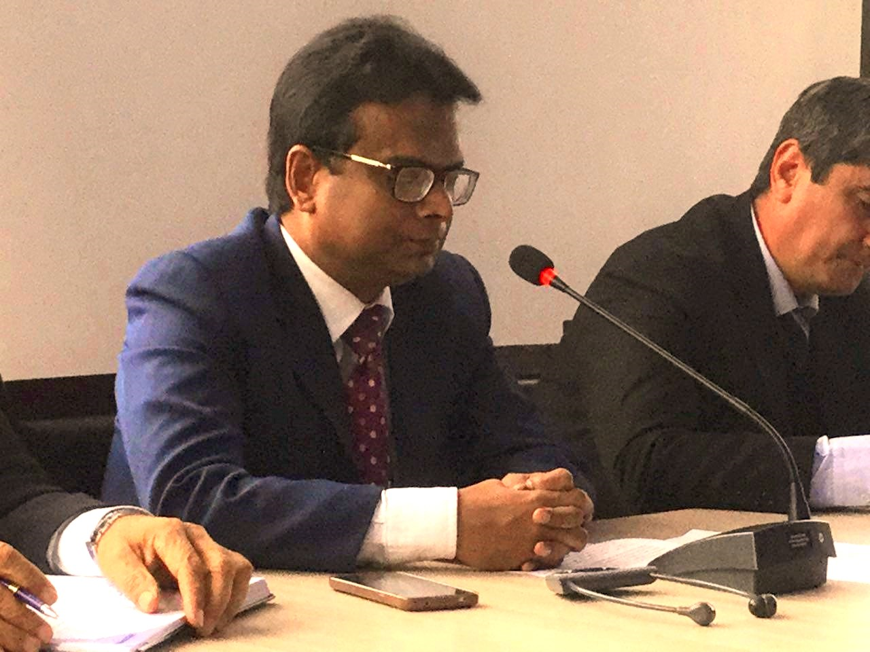
Shri Somnath Ghosh, Ambassador of India to Tajikistan addresses the audience
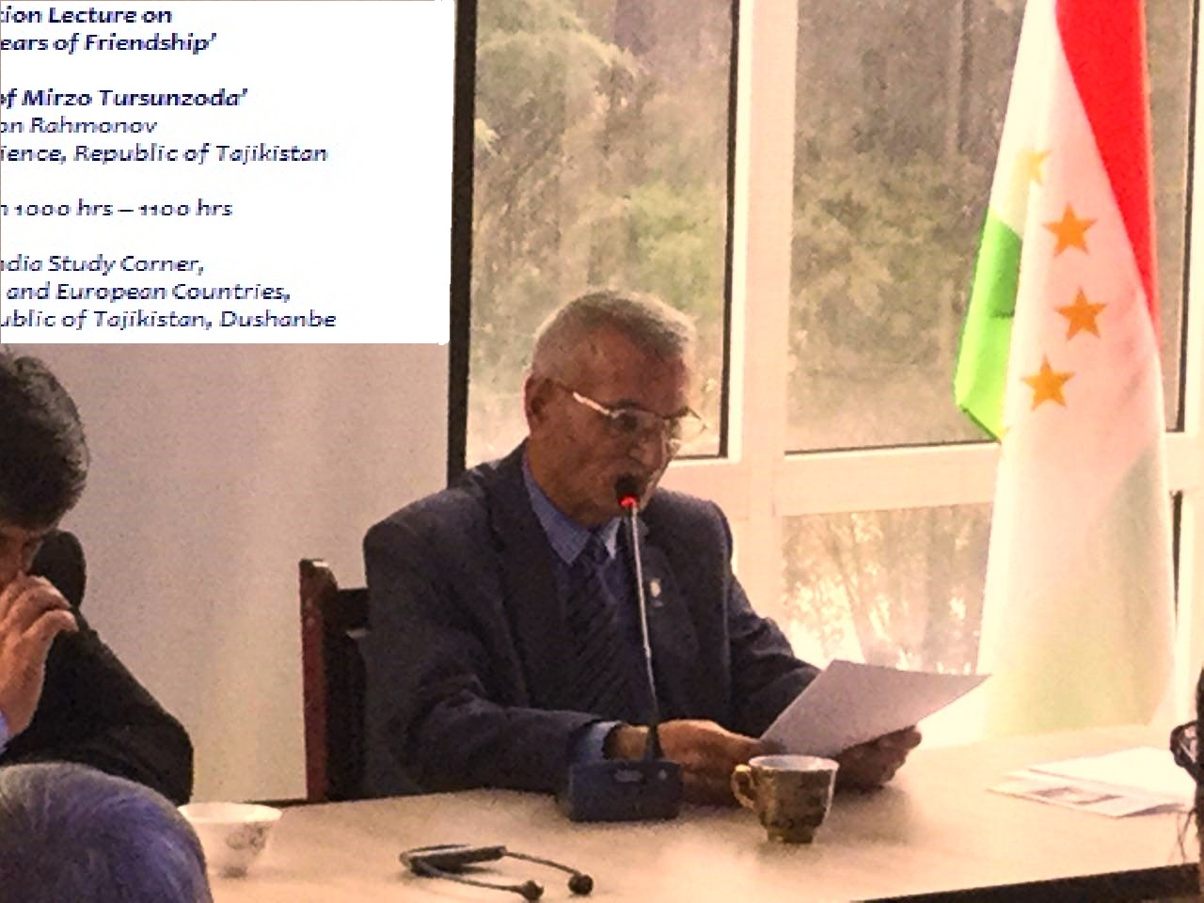
Mr. Shohzamon Rahmonov, Senior Member, Academy of Science, Republic of Tajikistan presents paper titles ‘India through the eyes of Mirzo Tursunzoda’
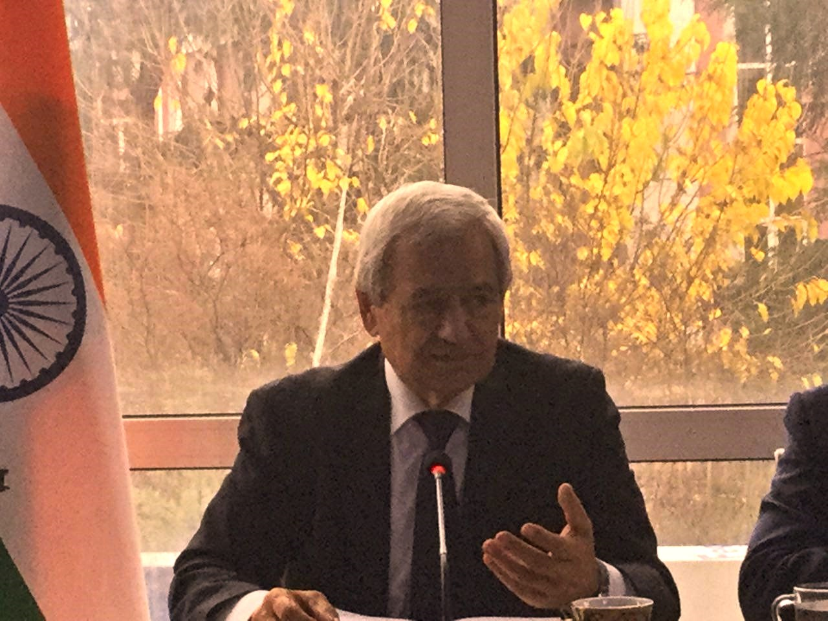
Prof. Habibullo Rajabov, Padma Shri awardee during discussion on the paper
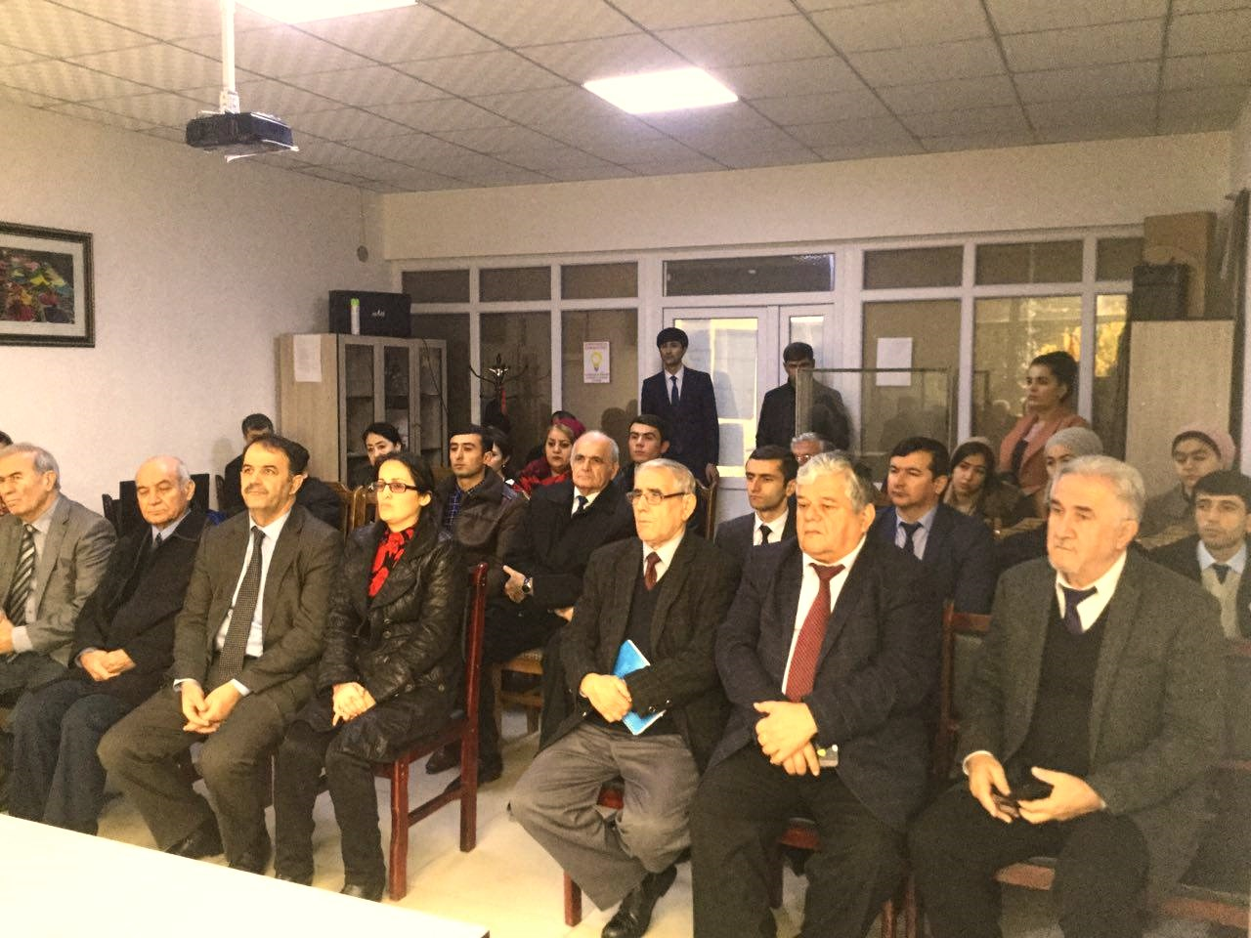
A cross section of the audience

