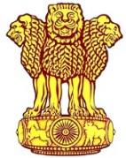 | Embassy of India  Ashgabat | 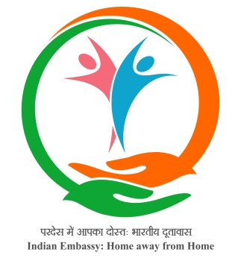

03rd Ayurveda Day Celebrated at Ashgabat
The 03rd Ayurveda Day was celebrated on 5th November, 2018 on the occasion of Dhanwatri Jayanti. The theme of this Ayurveda Day was
“Ayurveda for Public Health”
A ceremony was organized at 1600 hrs on 5th November, 2018 to mark the 3rd Ayurveda Day. Dr. Ambassador H E Mr. Azar A H Khan presided over the ceremony and highlighted the role of Ayurveda. Dr. Dinesh Baruah , AYUSH expert from Yoga & Traditional Medicine Centre , Ashgabat has highlighted the importance of Ayurveda Day and importance of Ayurveda in overall well-being.

***
Ashgabat, November 05, 2018
