 | Embassy of India  Ashgabat | 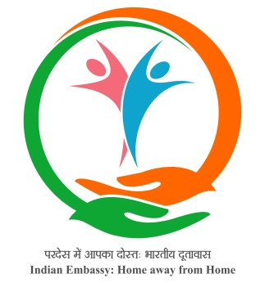

“Rashtriya Ekta Divas”, 2018

On the occasion of “Rashtriya Ekta Divas” Ambassador H.E Mr. Azar A. H. Khan administered the National Unity Pledge to all India Based officials at 1100 hrs.

In the evening a ceremony was held at the Chancery premises to celebrate the birth anniversary of Sardar Vallabhbhai Patel. Ambassador and other officials of the Embassy paid flower tribute to Sardar Patel. The ceremony was concluded with screening of a documentary depicting the life and accomplishments of Sardar Patel screened.

***

Ashgabat; October 31, 2018.

