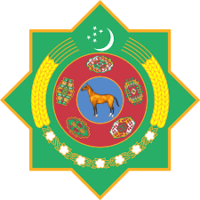 |  | 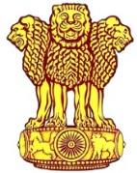
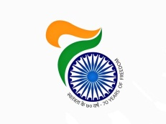
Embassy of India
Ashgabat

Dance performance by Bollywood Group
To celebrate India @ 70 and Independence Day of India, Embassy of India in Ashgabat organized two Bollywood dance shows of ICCR’s sponsored “Bollywood Rockers” Group with support of Ministry of Culture of Turkmenistan.
The 14-member group presented splendid cultural program based on Bollywood theme songs depicting variant colours of India on 30-31st August 2018 at Watan Kino-theatre. The events were formally inaugurated on 31st August, 2018 with lighting of traditional lamp by H.E. Mr. Nursahet Shrimov Deputy Minister of Culture, Government of Turkmenistan and H. E. Mr. Azar A H Khan Ambassador of India to Turkmenistan.
The theater was packed to the capacity on both days. Besides a large number of Turkmen nationals, performances were attended by Head of Foreign Missions, UN Organizations, Diplomatic Community and representatives of the Governments of Turkmenistan.
***
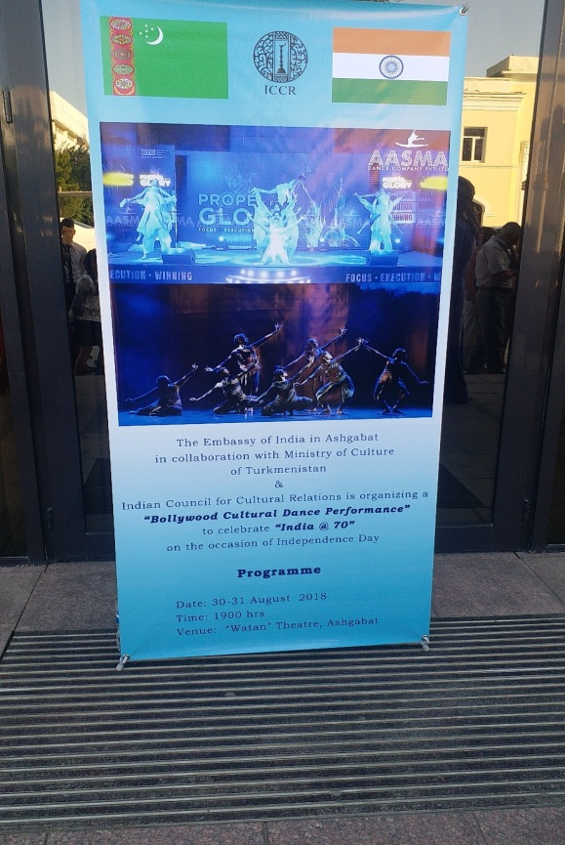
Performance by Bollywood Group 30-31 August 2018
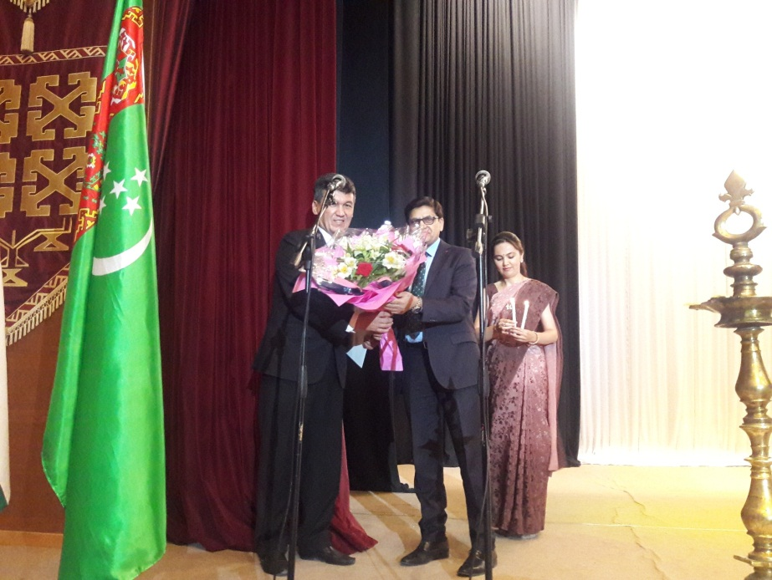
Performance by Bollywood Group: Welcoming the Chief Guest

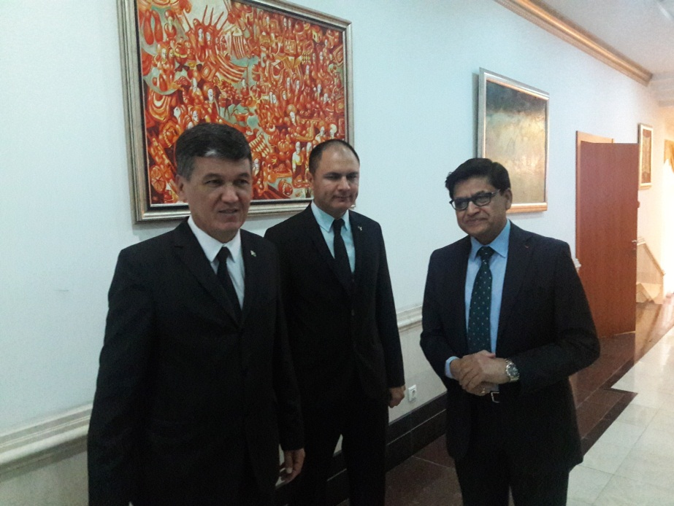
Performance by Bollywood Group: Welcoming the Chief Guest

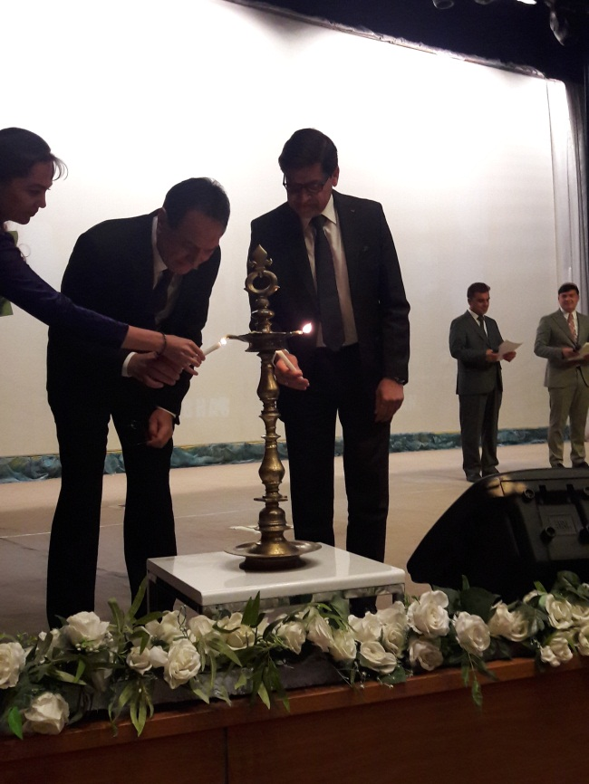
Performance by Bollywood Group: Lighting the lamp
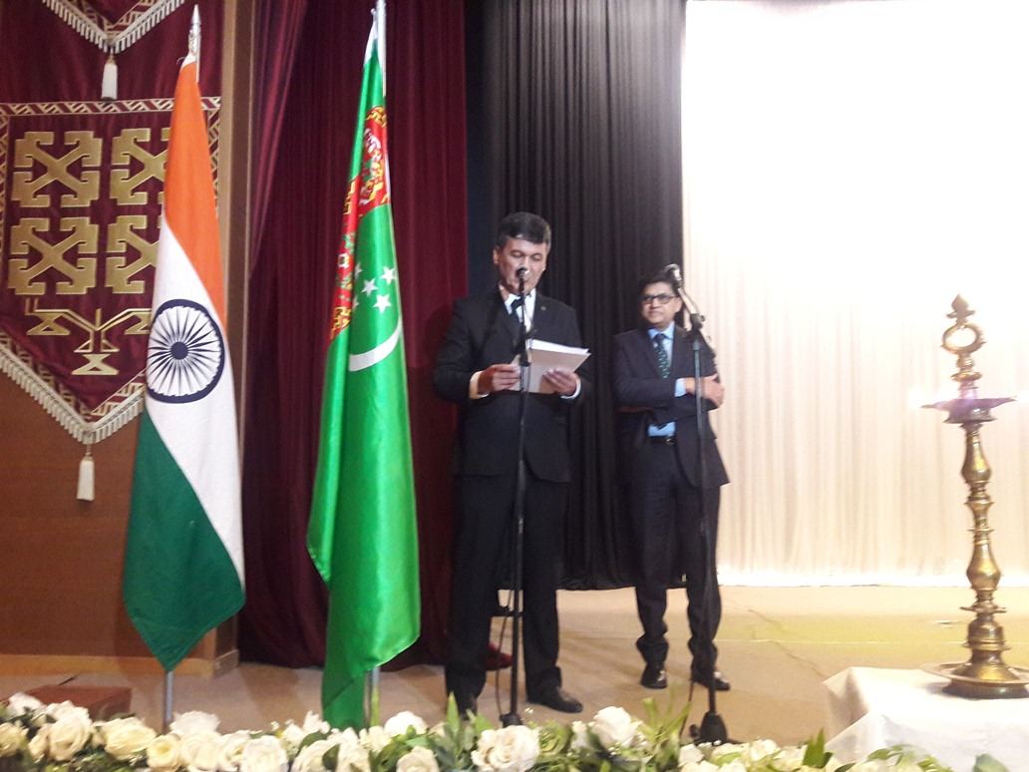
Performance by Bollywood Group: Address by the Chief Guest
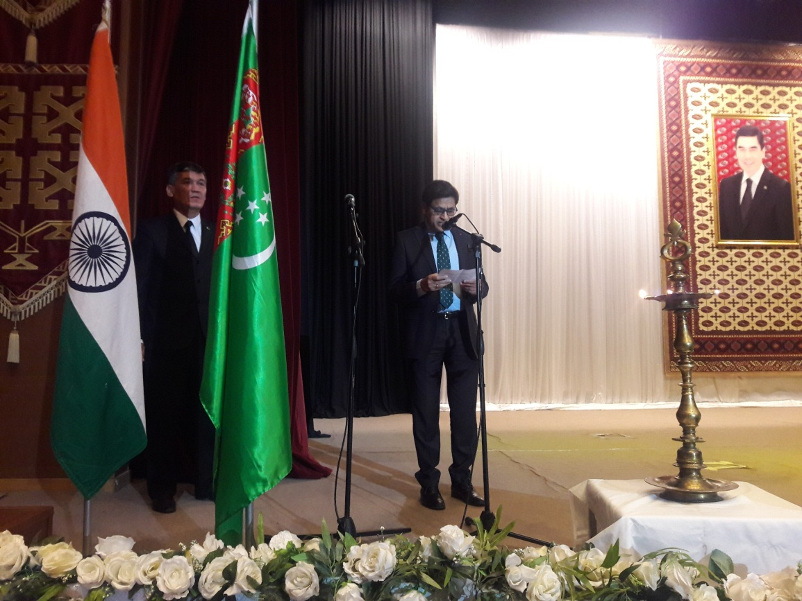
Performance by Bollywood Group: Address by the Ambassador
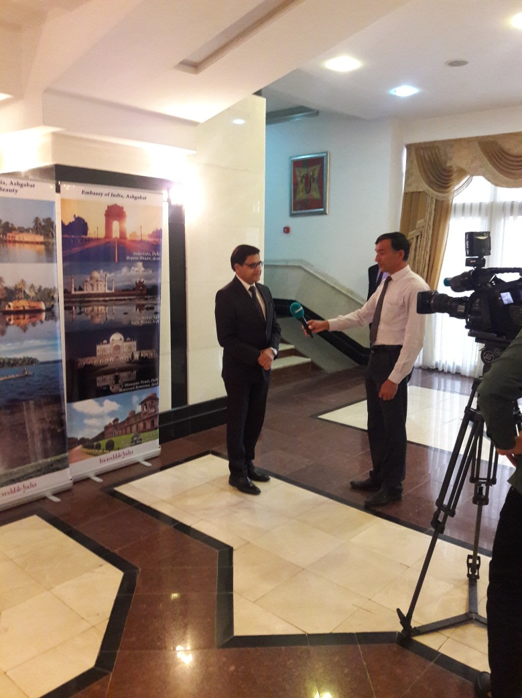

Performance by Bollywood Group: Interview of the Ambassador

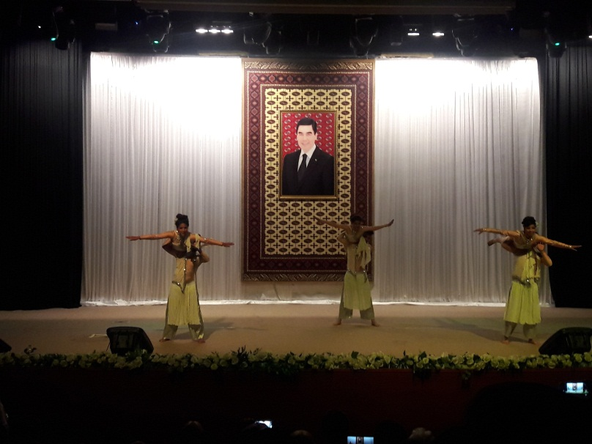 | 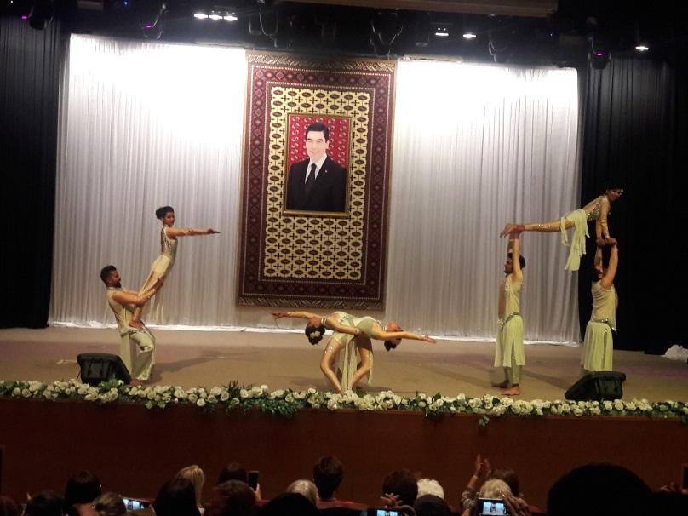
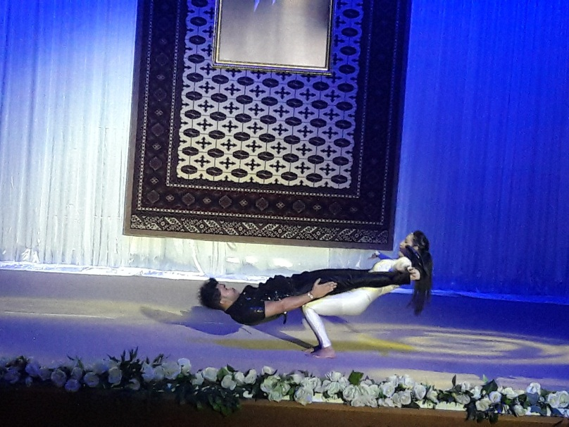 | 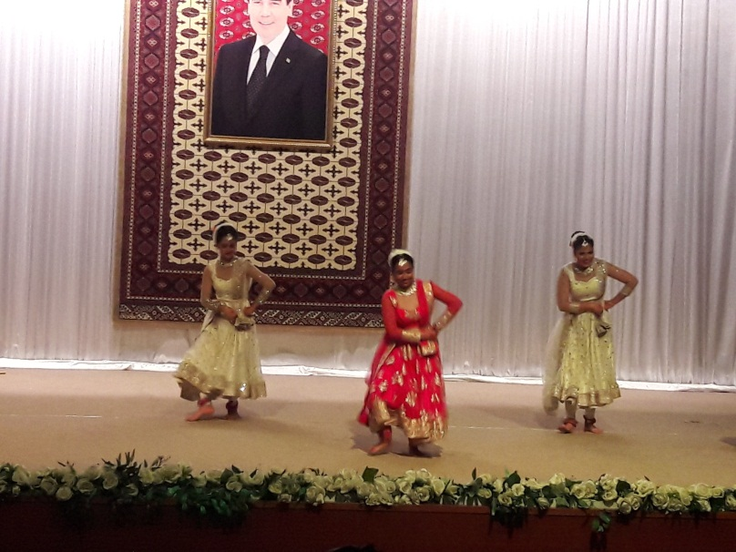
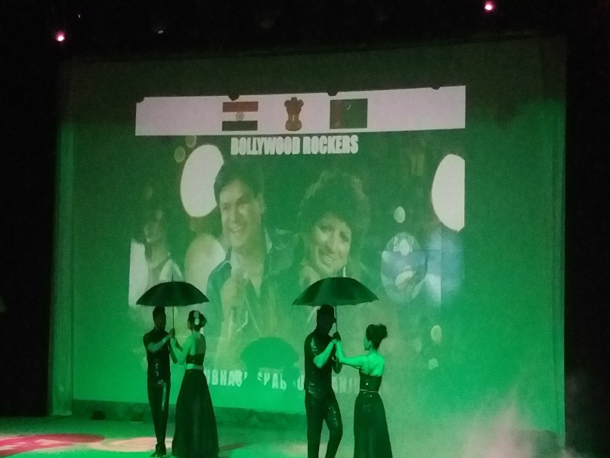 | 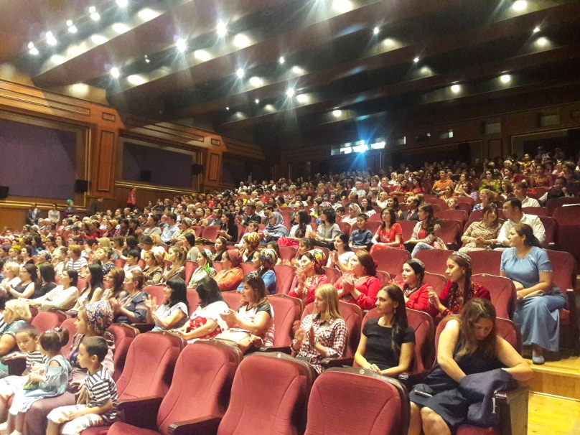
Performance by Bollywood Group Glimpses

